Create a Simple Business Rule

Event Profile Setup

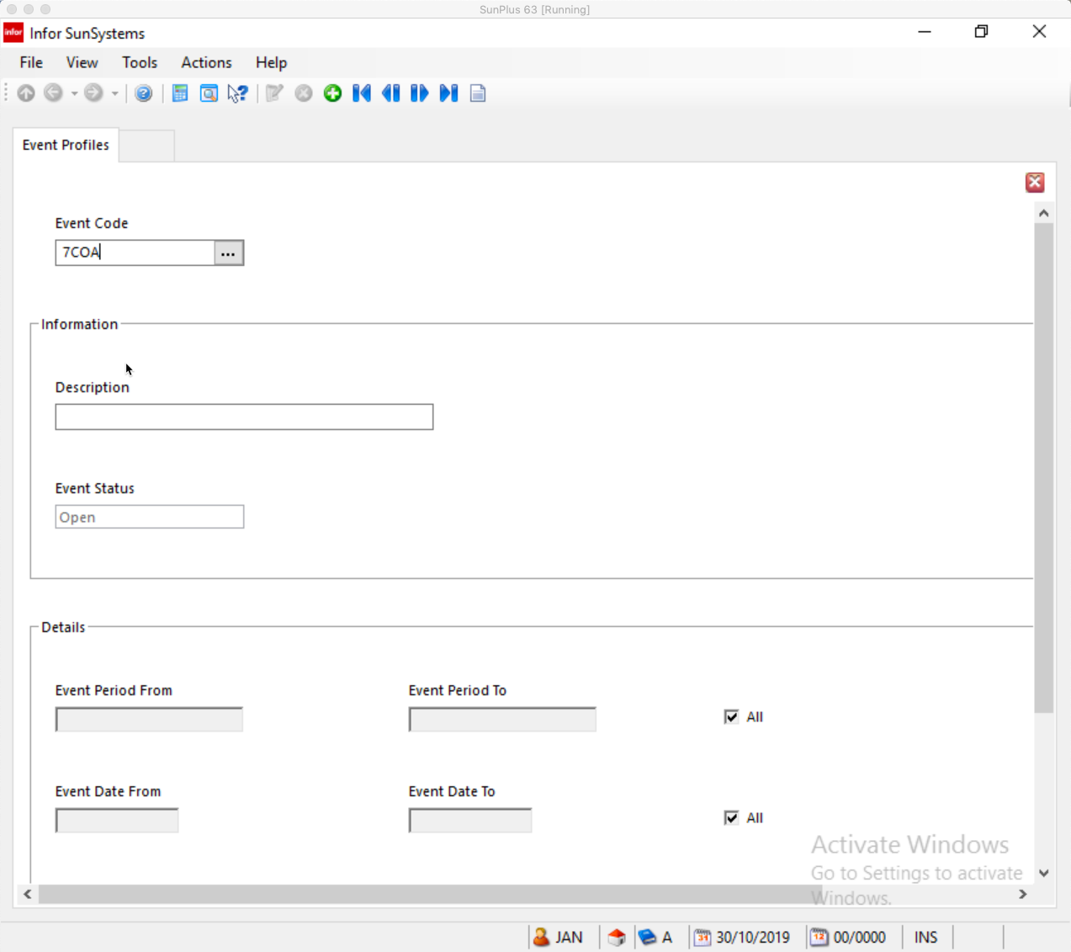
- Event Code Must be unique
- Click OK
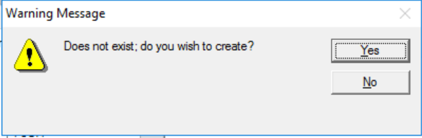
- Click Yes
- Description Enter Description of the Event
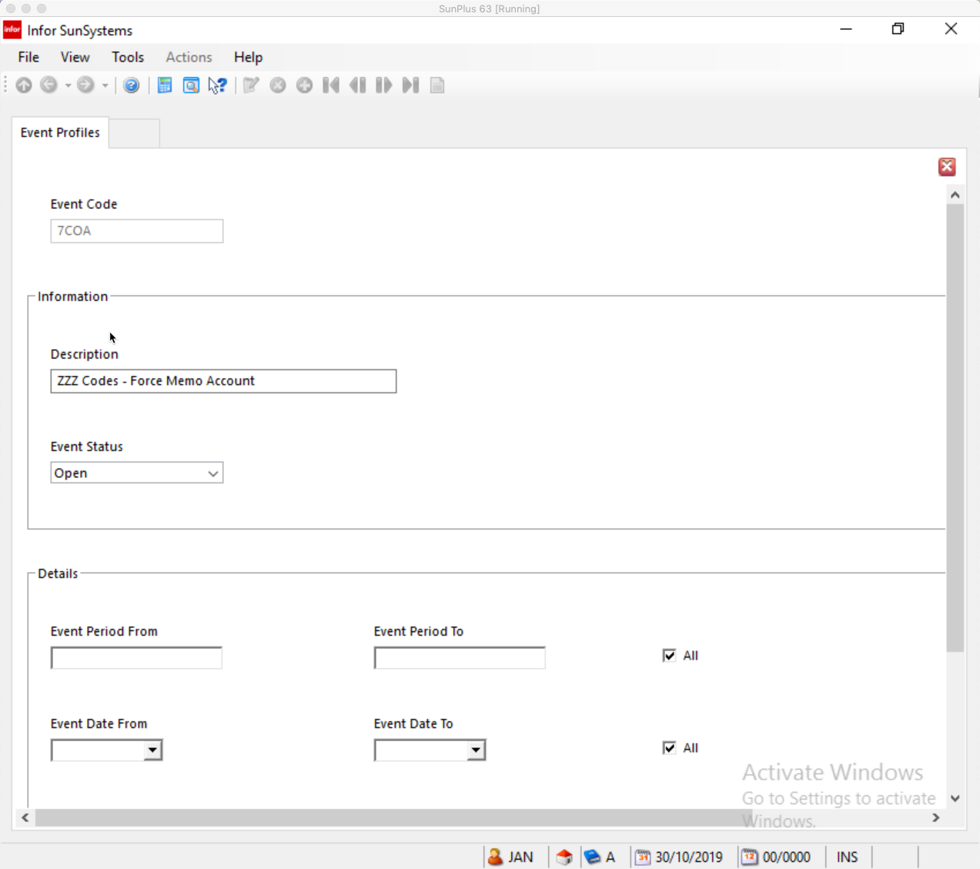
- Event Period From/To Enter effective Period range
  - Leave blank for All
- Event Date From/To Enter effective Date range
  - Leave blank for All
- Click Details button

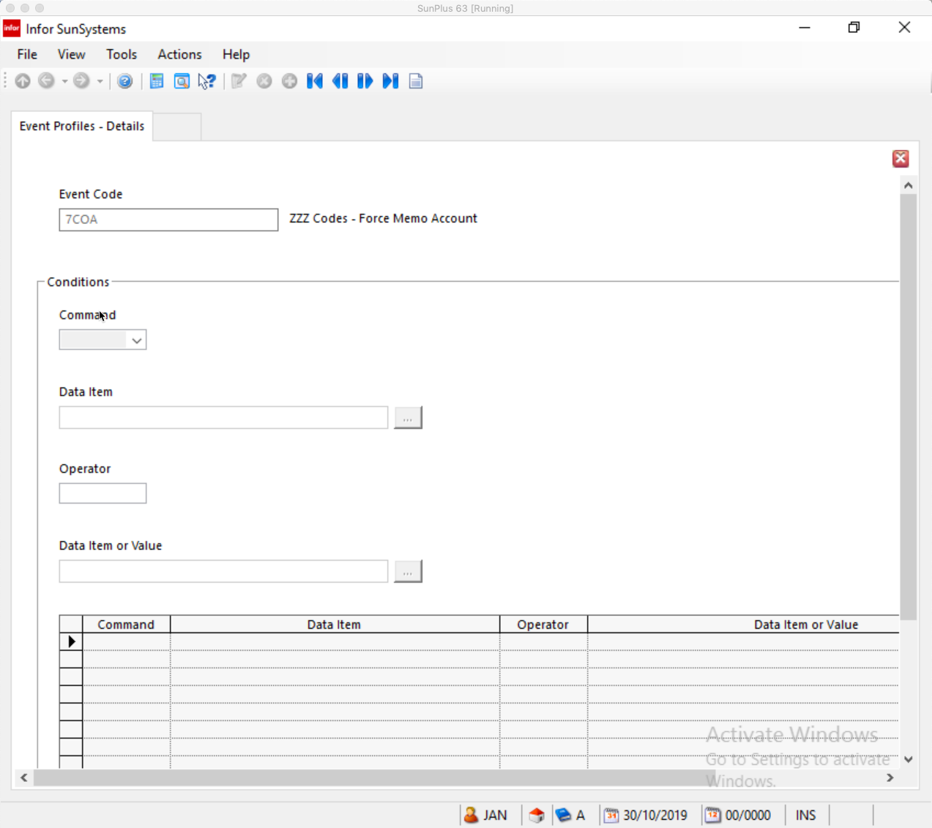
- Click Create
- Command IF – the first command is always IF
- Click OK

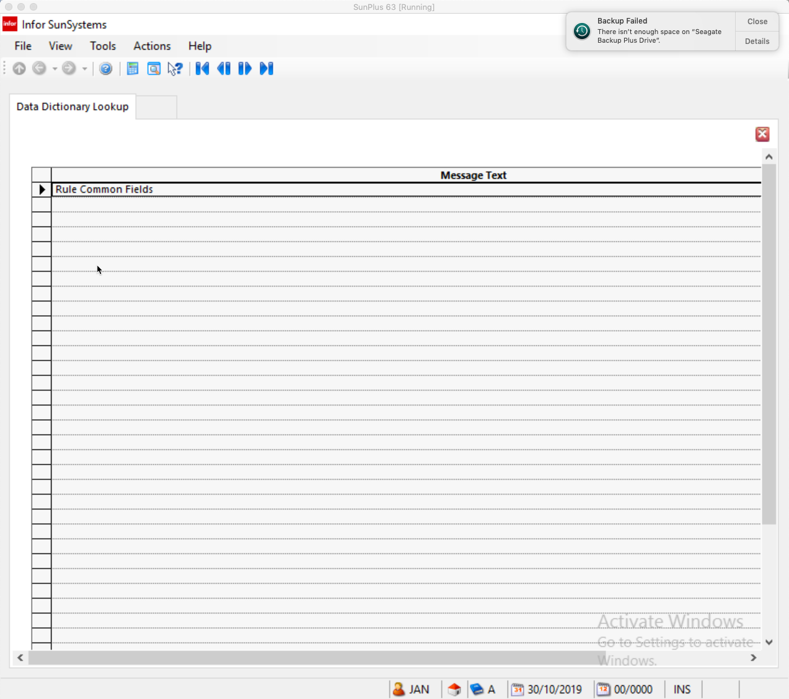
- Click OK

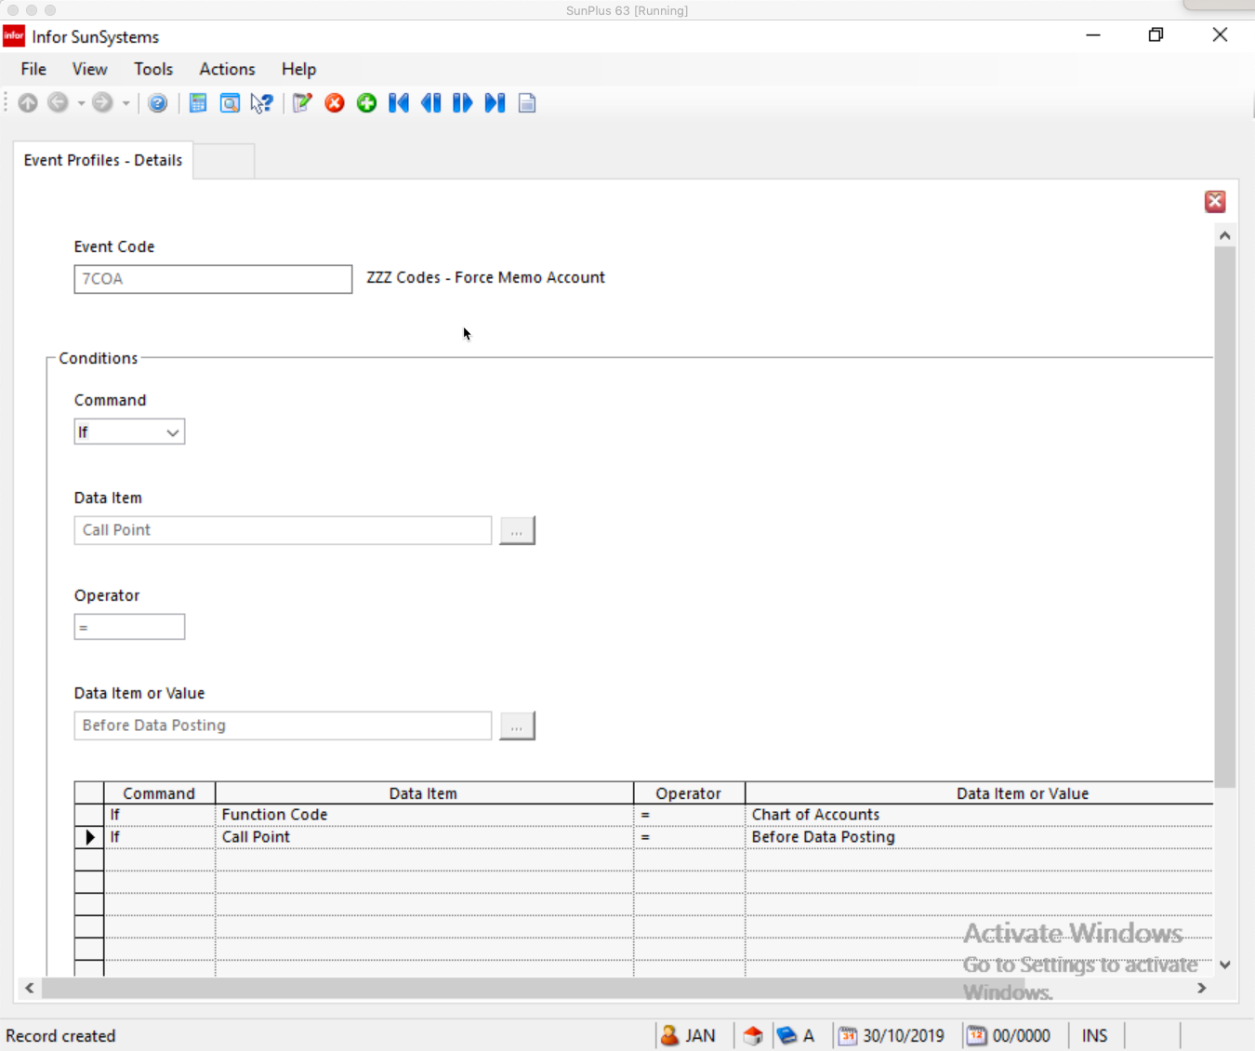
- Click OK

Rule Messages
- Rule Messages can be used to display information to the user. They are used by DISPLAY and ERROR Action Statements
  - ERROR Messages display the message and stop the entry from being posted
  - DISPLAY Messages display the message and allow the entry to continue processing
- Rule Messages can be used on more than one Rule Set
- Rule Messages must exist before the Rule Sets to which they will be attached

- Start by deciding whether a message will be needed for this Business Rule
  - If so, does it already exist?
- Go to Rule Messages

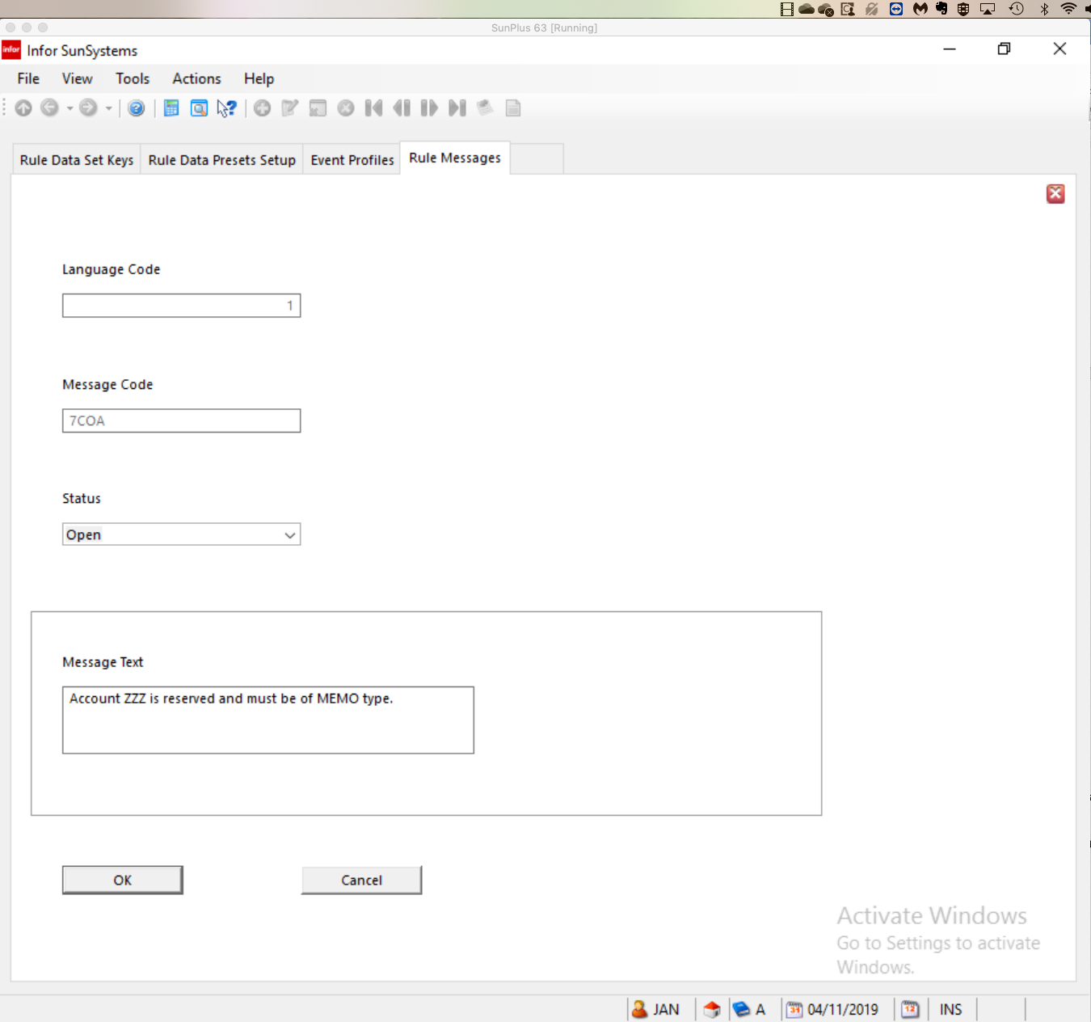
- Enter the Language Code
- Enter a unique Message Code – make it meaningful to help identify the message’s use
- Set Status if necessary
- Enter the Message Text you need
- Click OK

Determine whether you need to set up any redefinitions
  - A redefinition creates a new data item as a subset of an existing data item
    - Avoid using redefinitions as much as possible
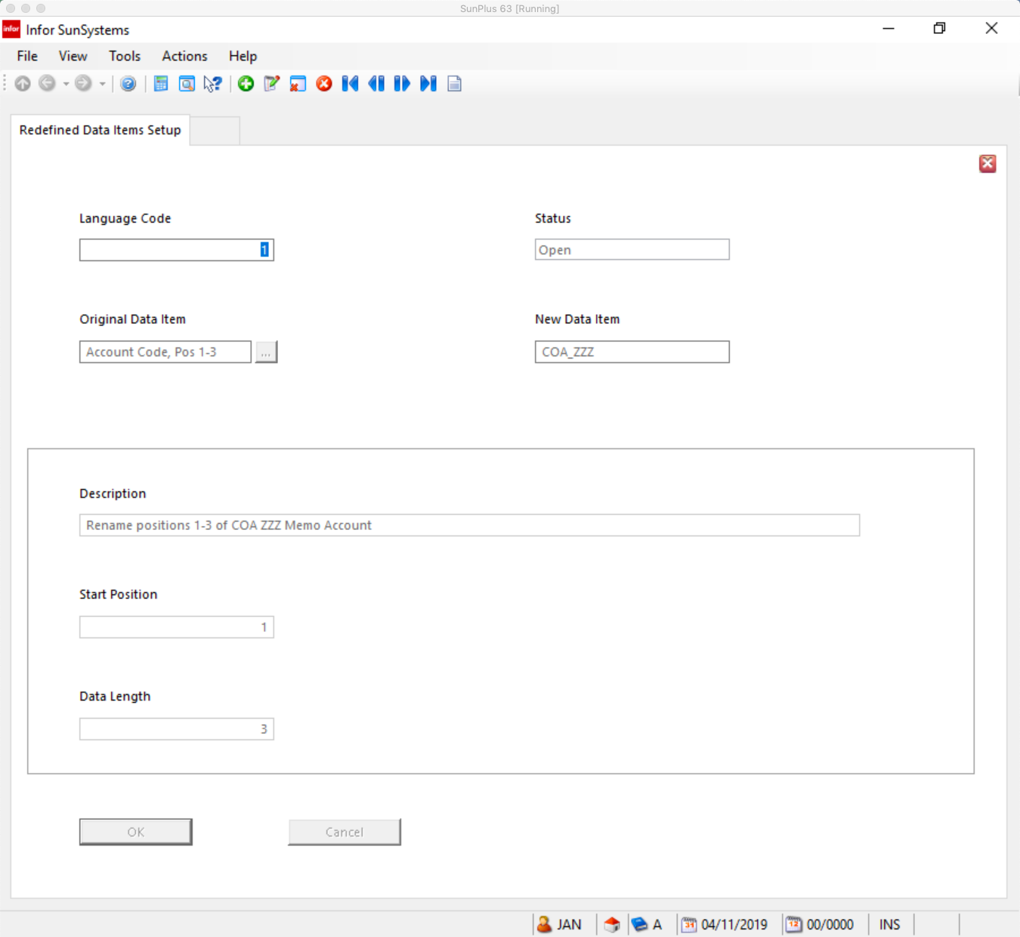
  - Language Code
  - Status
  - Original Data Item the Data Item to be redefined
  - New Data Item Name of the new, redefined, Data Item
  - Description Description of the new Data Item
  - Start Position The position of the character in the parent Data Item that marks the
beginning of the new Data Item
    - Defaults to 1
  - Data Length The number of characters, from the Start Position, to be included in the
new Data Item
    - Defaults to length of Data Item
  - Save

Create a Rule Set
  - A Rule Set contains a series of conditions and action to apply to the data entered for a SunSystems function
  - A Rule Set is defined for an Event Profile
    - It consists of a series of condition statements followed by a series of action statements – or only of a series of actions if they are required under all conditions
    - It can contain up to 50 condition statements and up to 50 Action statements
    - Condition statements always start with IF or OR
    - Action statements are always defined after the condition statements
    - A Rule Set is a decision table
      - Decision columns associate one or more actions with the result of one or more condition statements
      - A Rule Set contains up to 10 decision columns
      - The results of a condition statement, either Y(es) or N(o) is indicated in a decision column
      - Action to be performed for a particular result is indicated by an X in the appropriate decision column on the Action statement
    - You can have multiple IF and OR statements

  - SunPlus convention is that the Rule Code should be:
    - Processed in alphabetical order
    - Logically similar
    - Composed of similar items

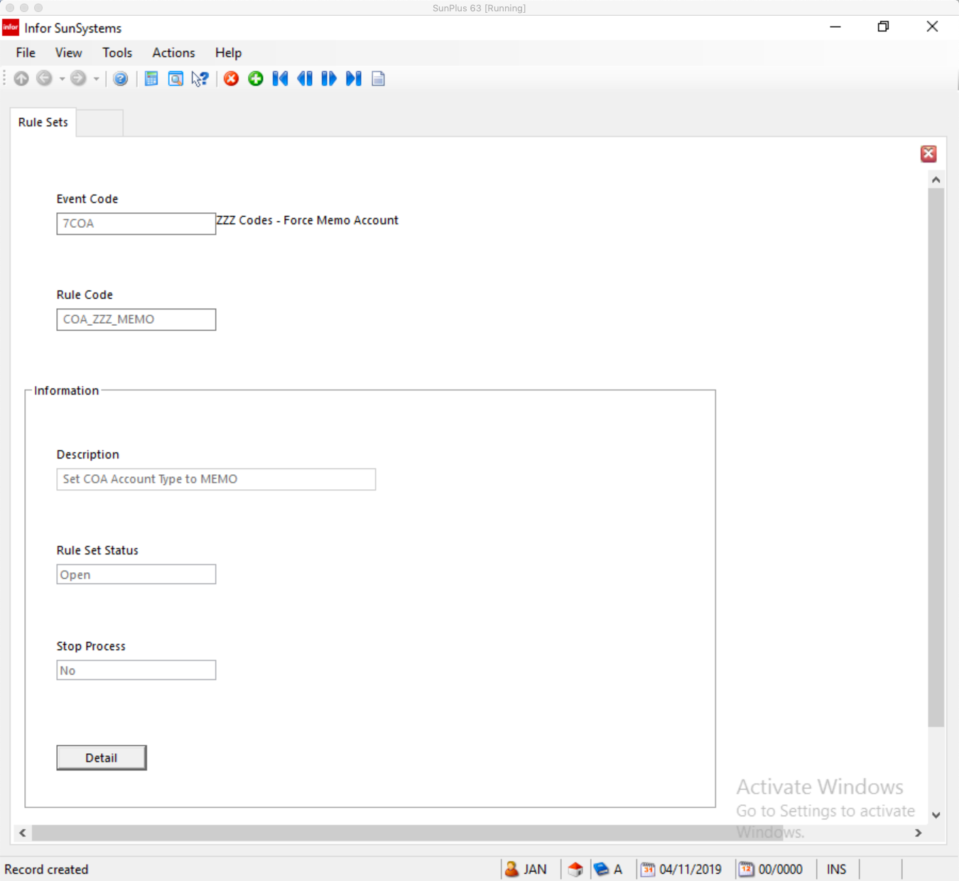
  - Enter Rule Code
  - Click OK
  - Enter Description
  - Click Detail button

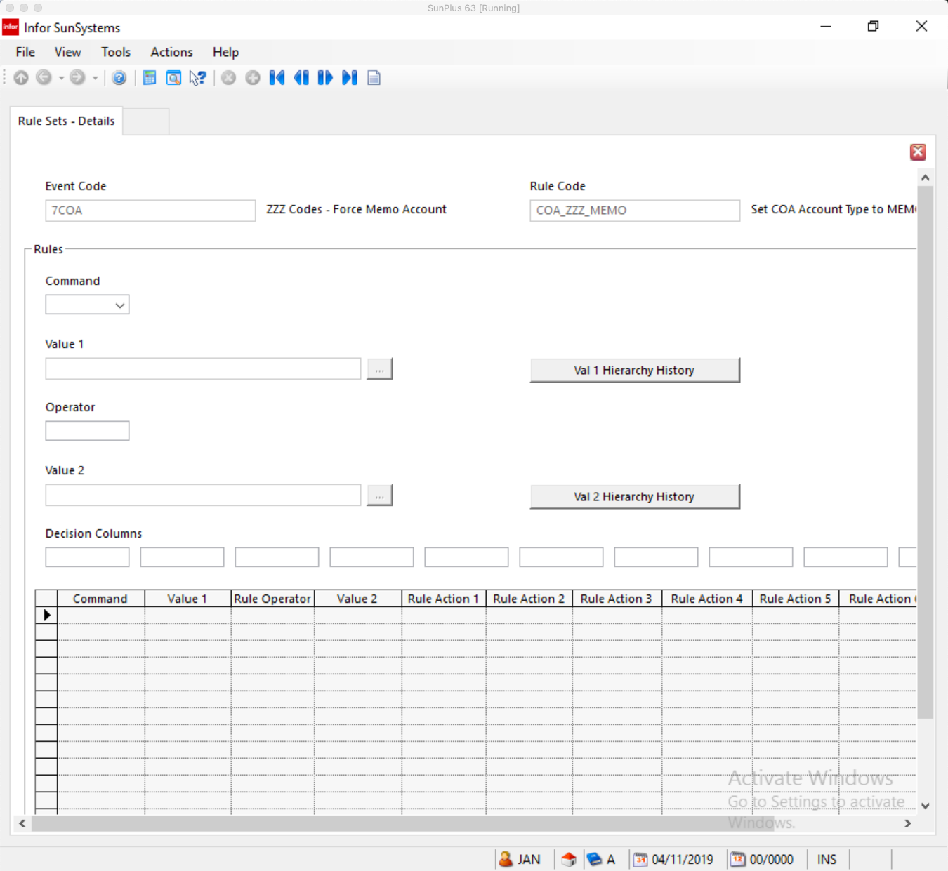
  - Click Create button
  - Enter Command
  - Click OK
  - Enter Value 1
  - Click OK
  - Enter Operator
  - Click OK
  - Enter Value 2
  - Click OK
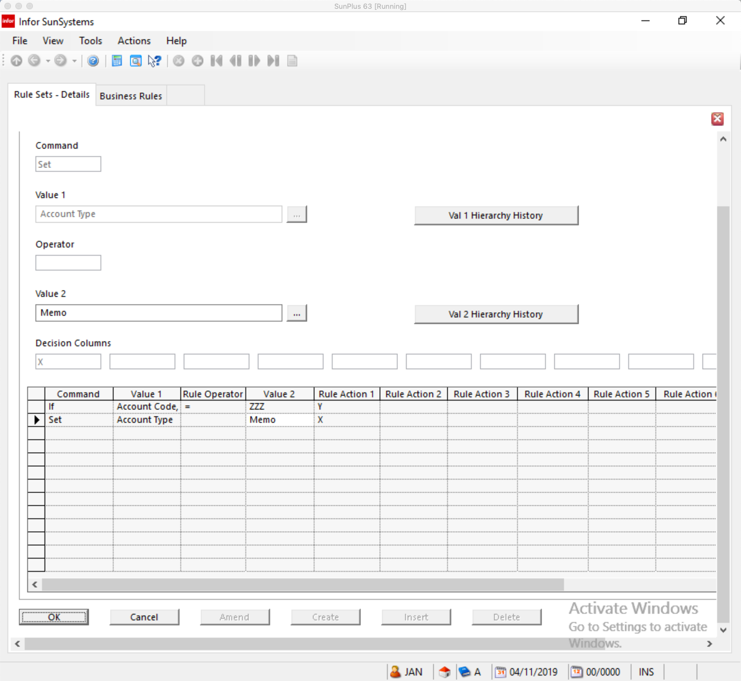

Sample Business Rule Setup

Event Profile

The sample set of Business Rule screens is associated with a Business Rule intended to establish defaults for Chart of Accounts.

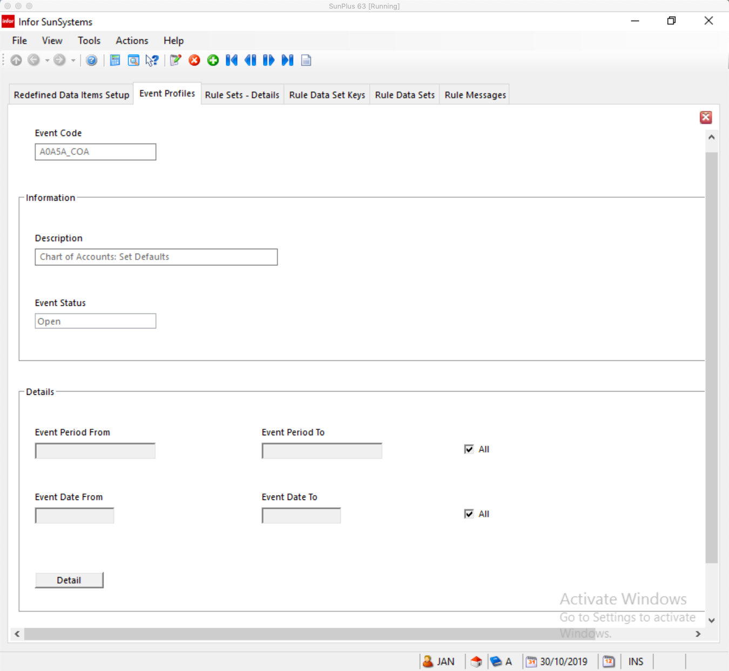
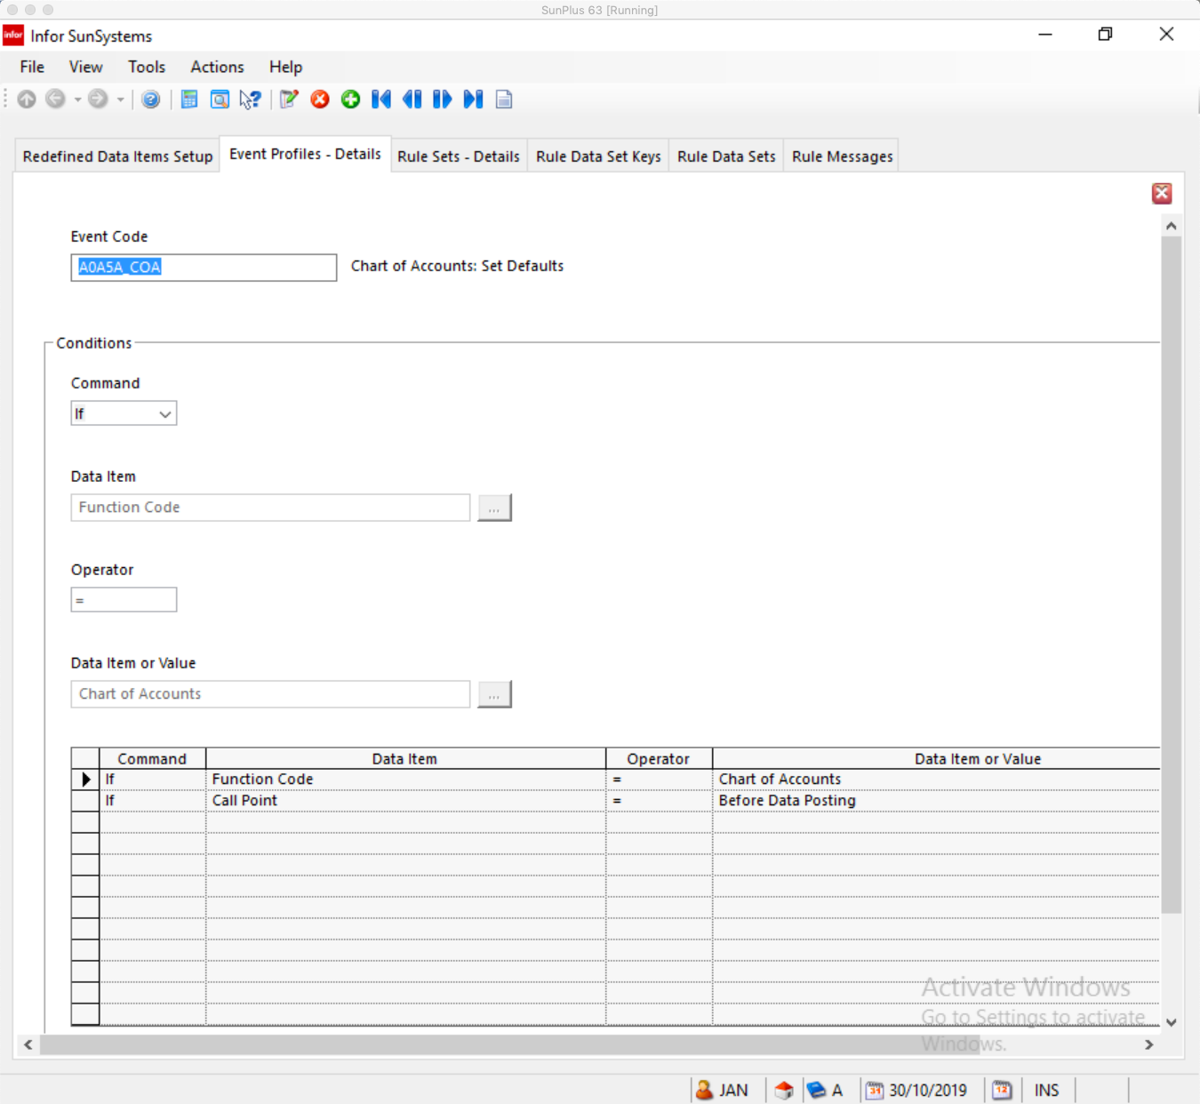

Rule Messages

Several Rule Messages have been set up for Chart of Accounts defaults.
I have included screenshots of each of them below.

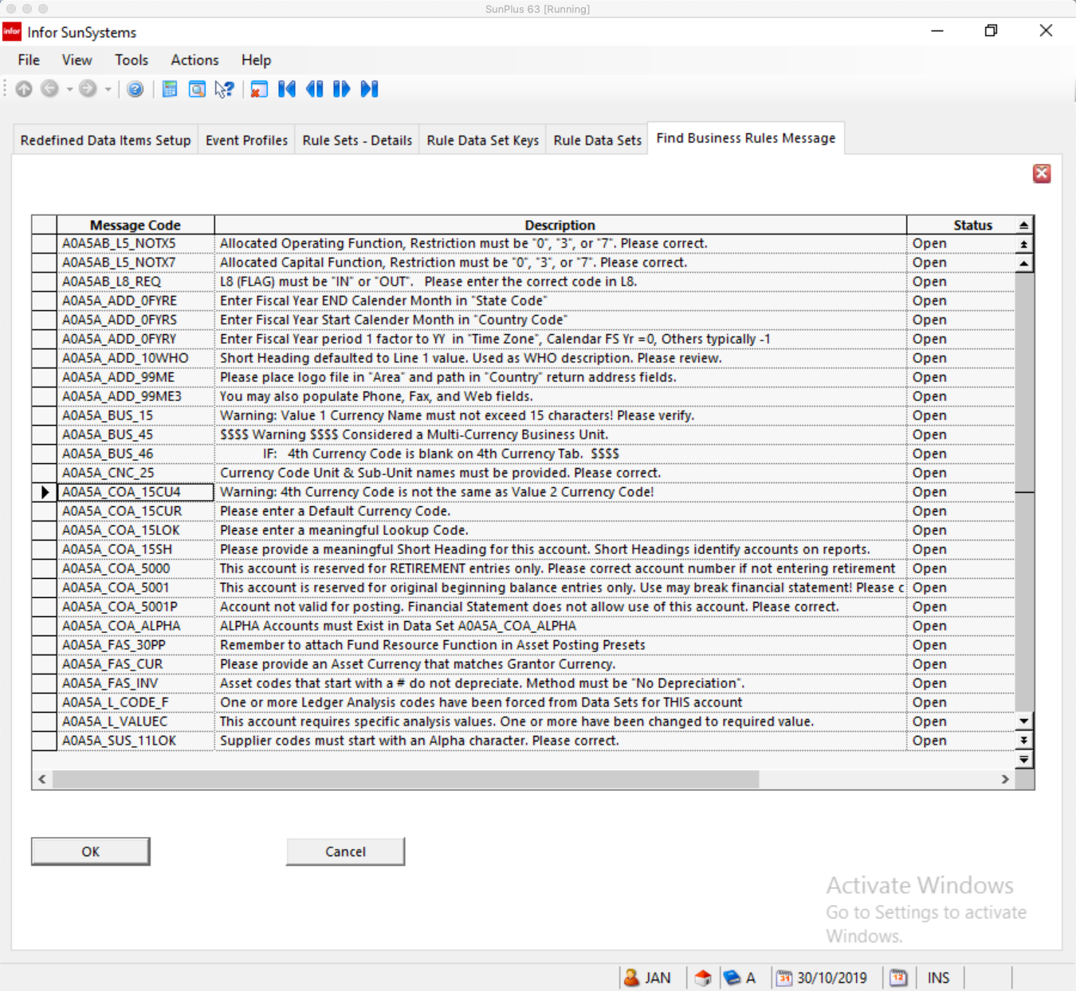
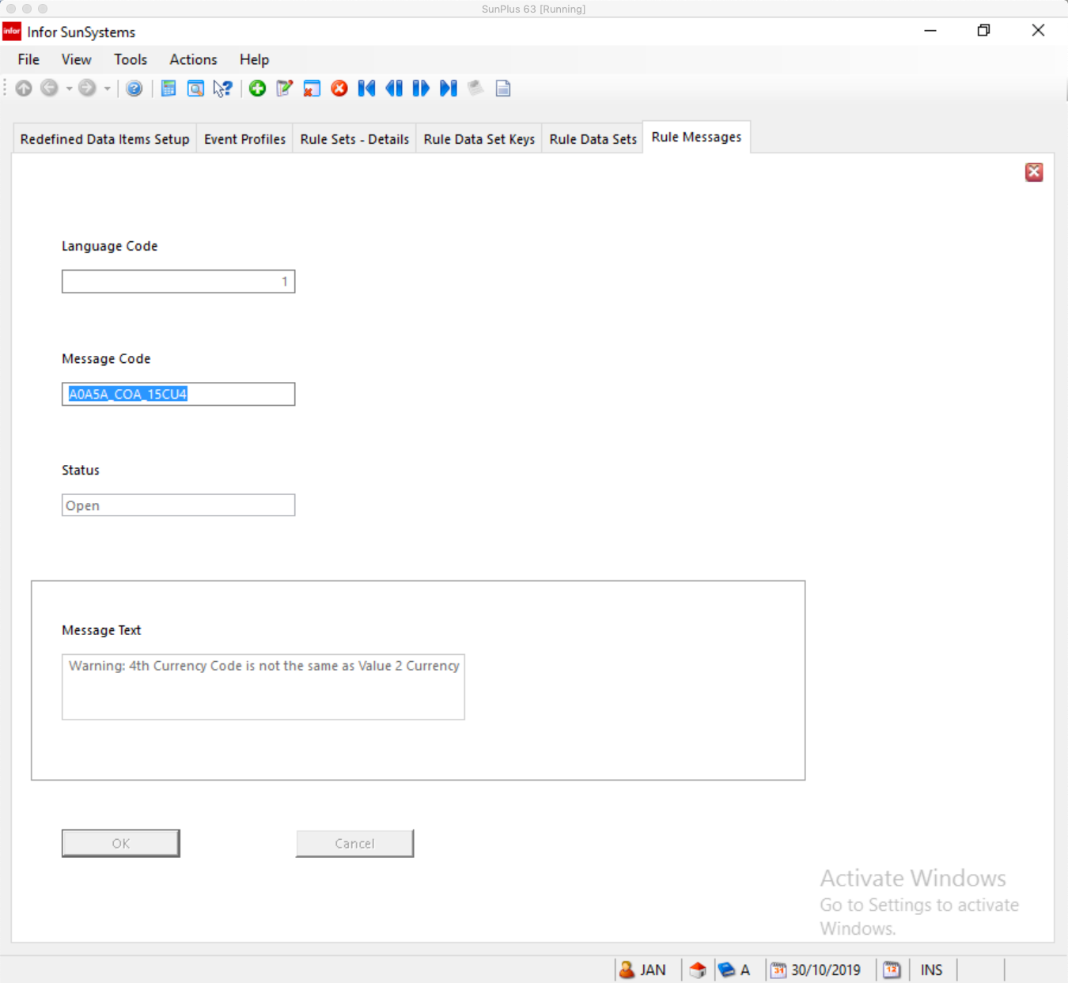
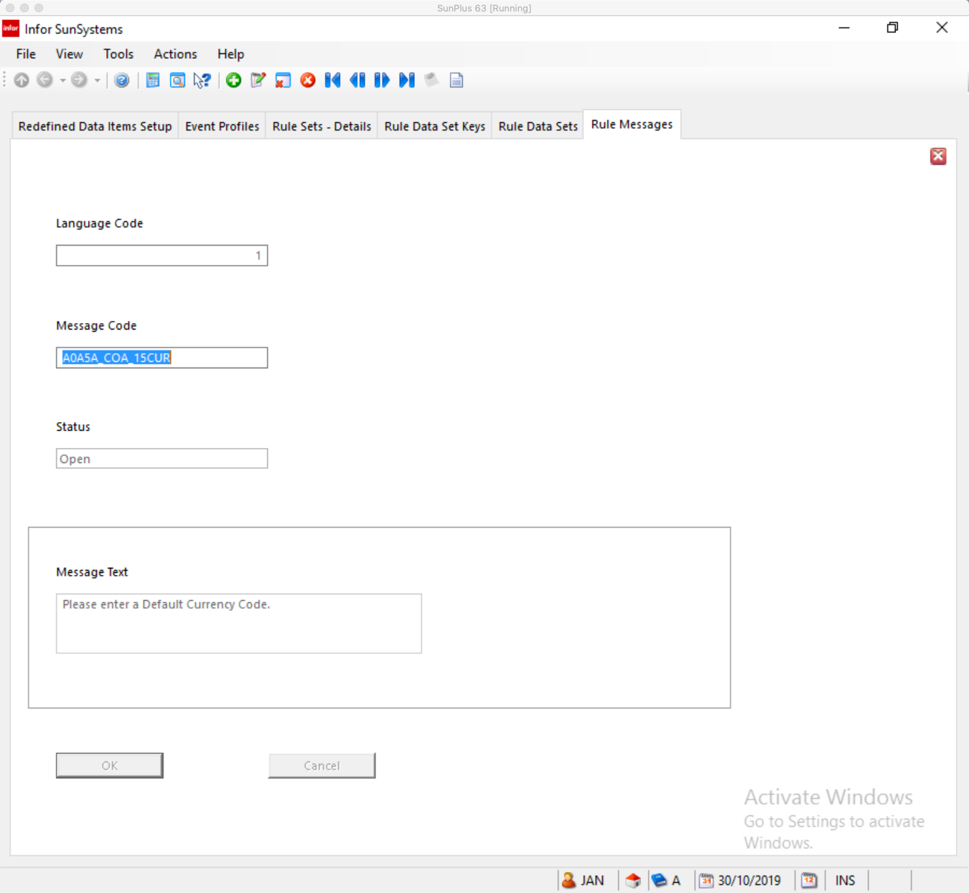
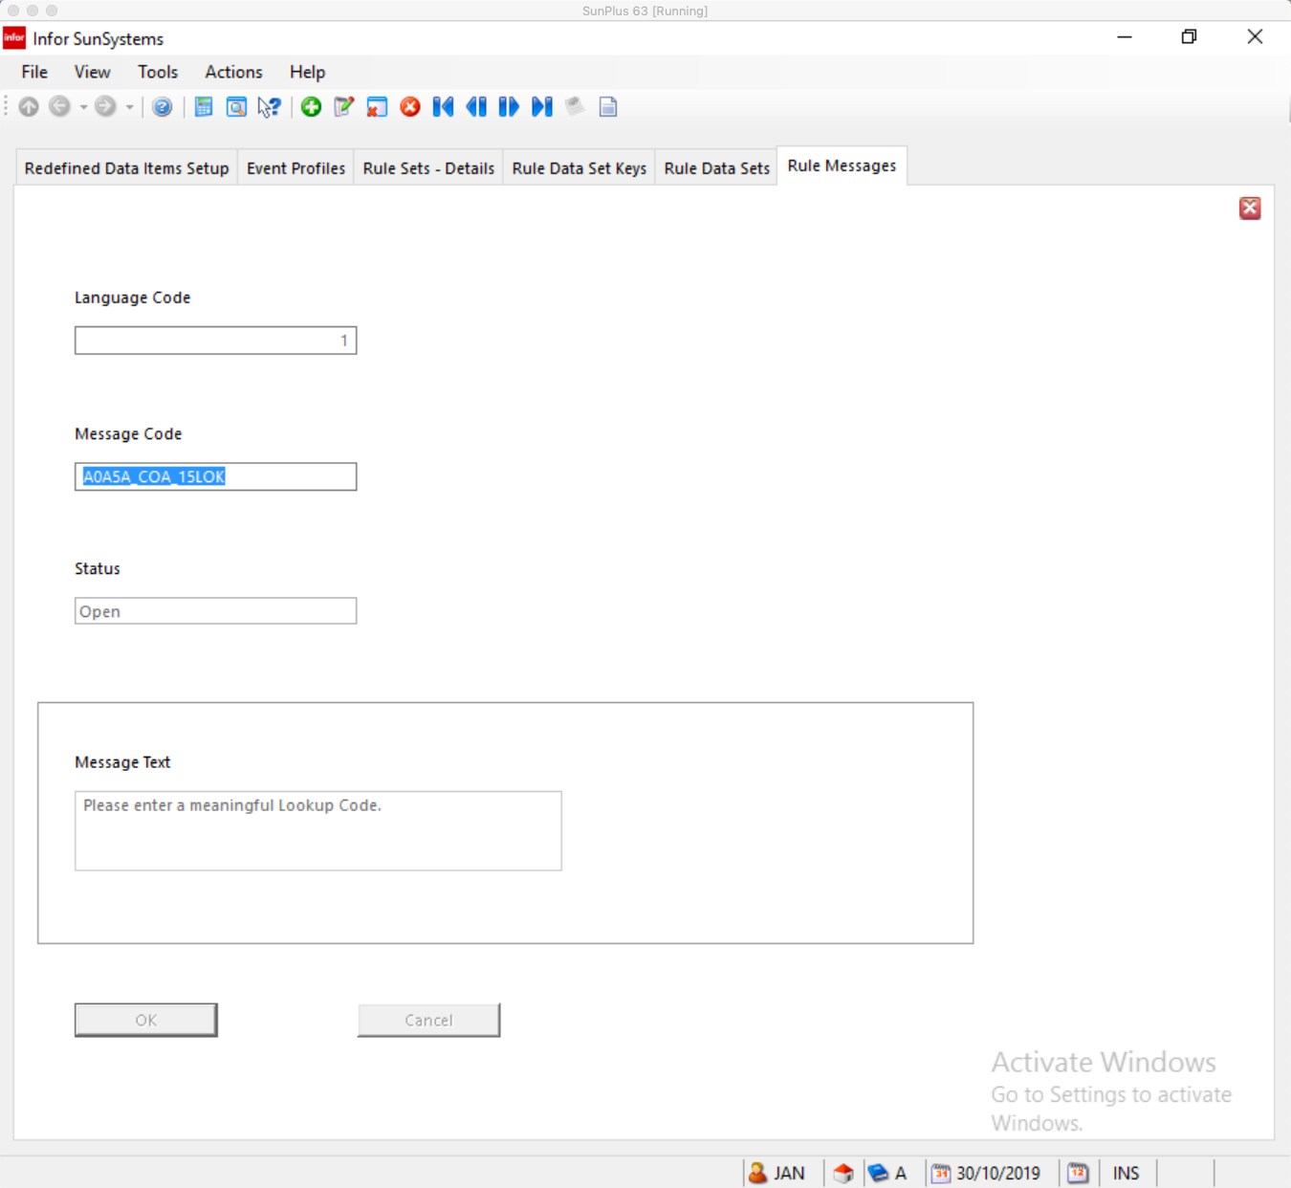
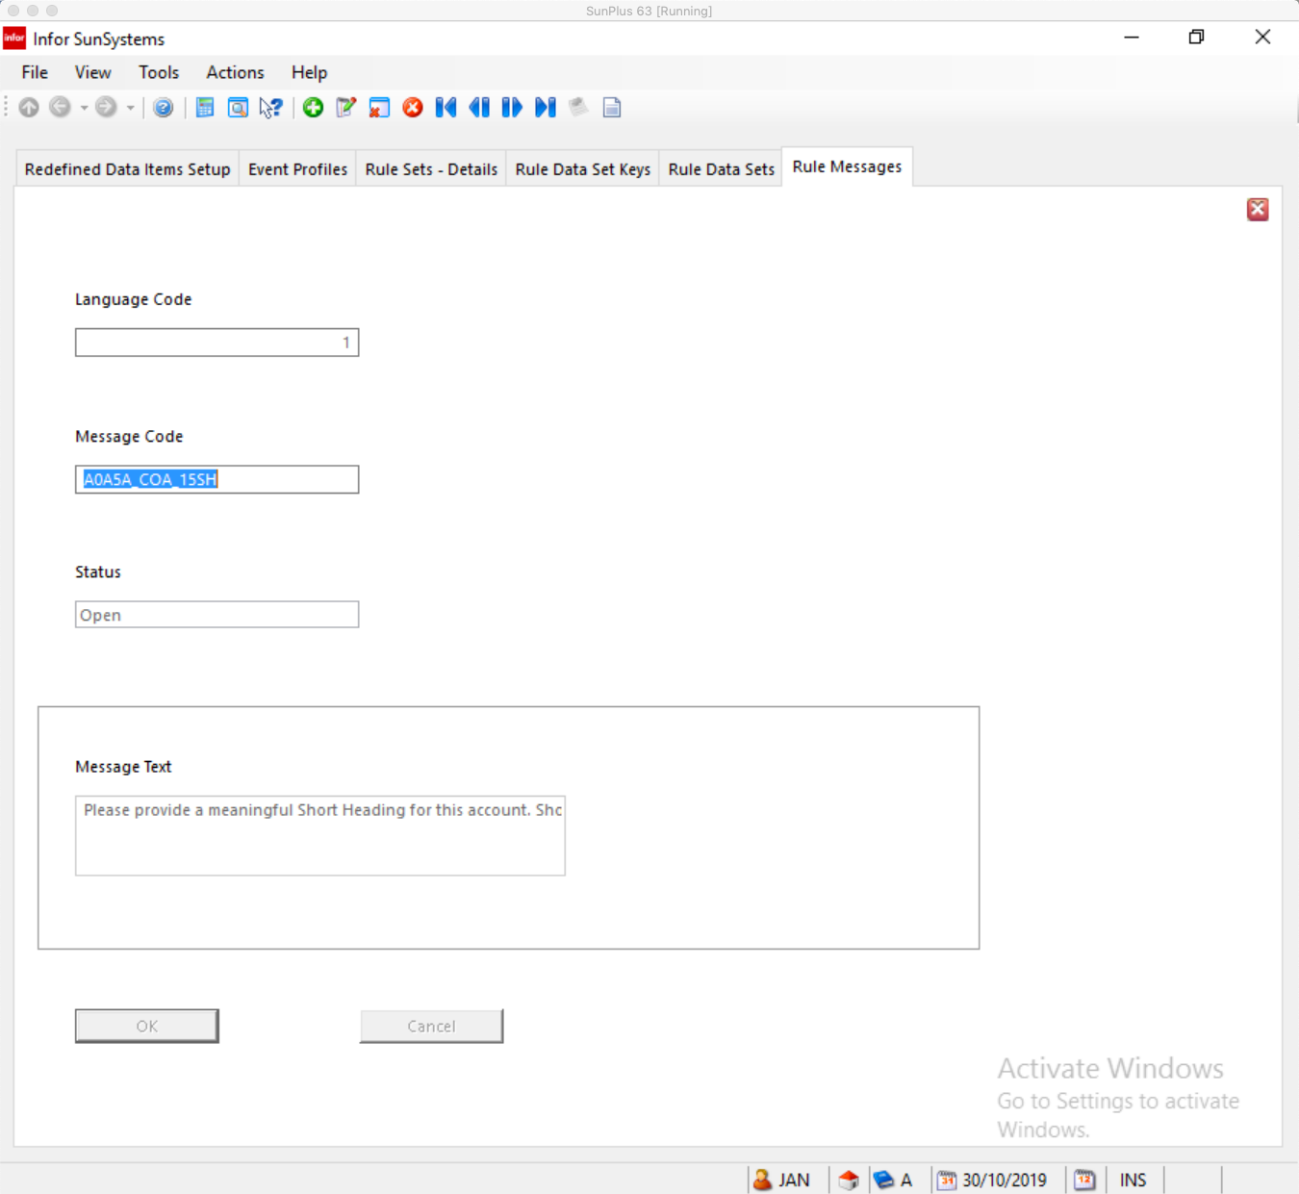
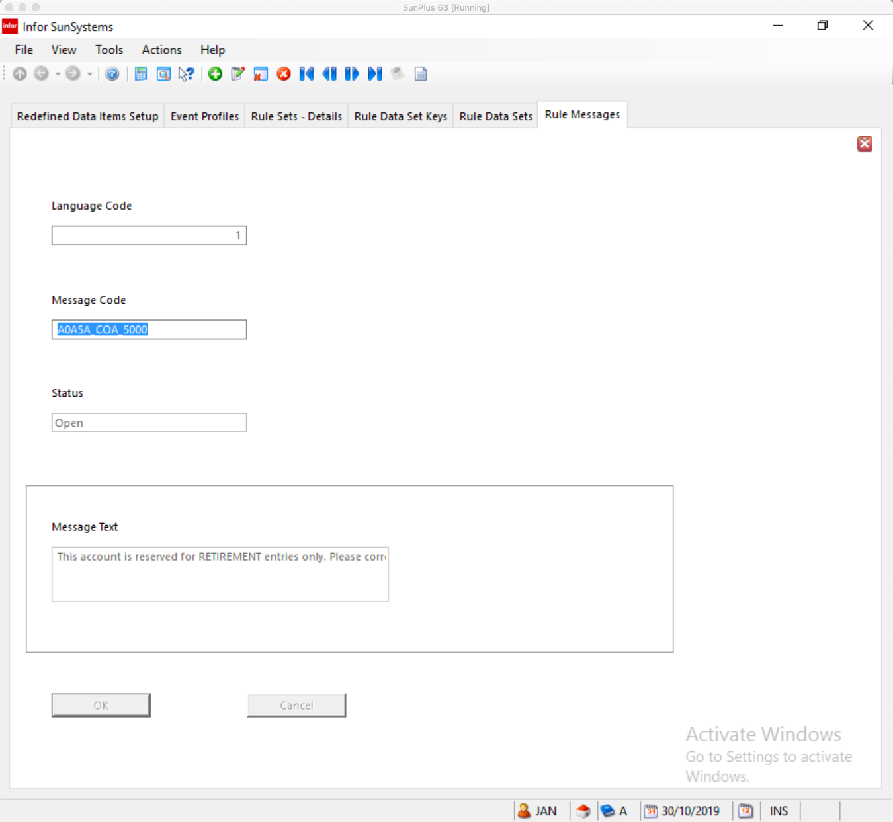

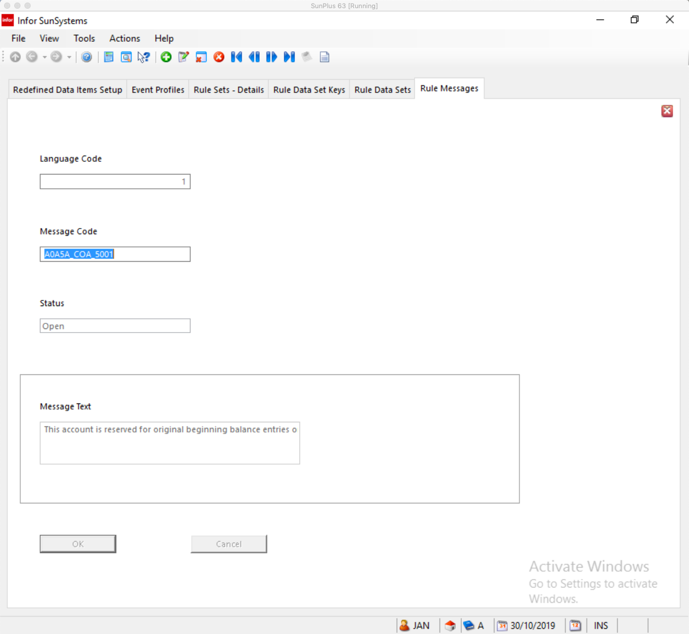
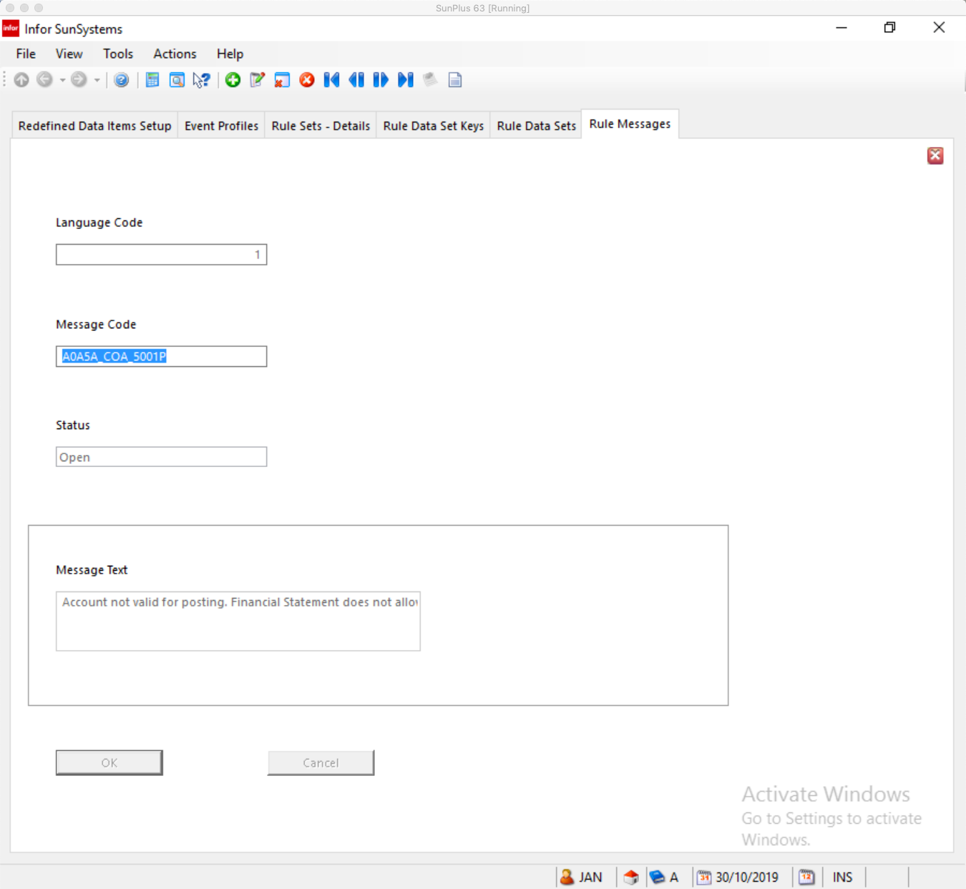
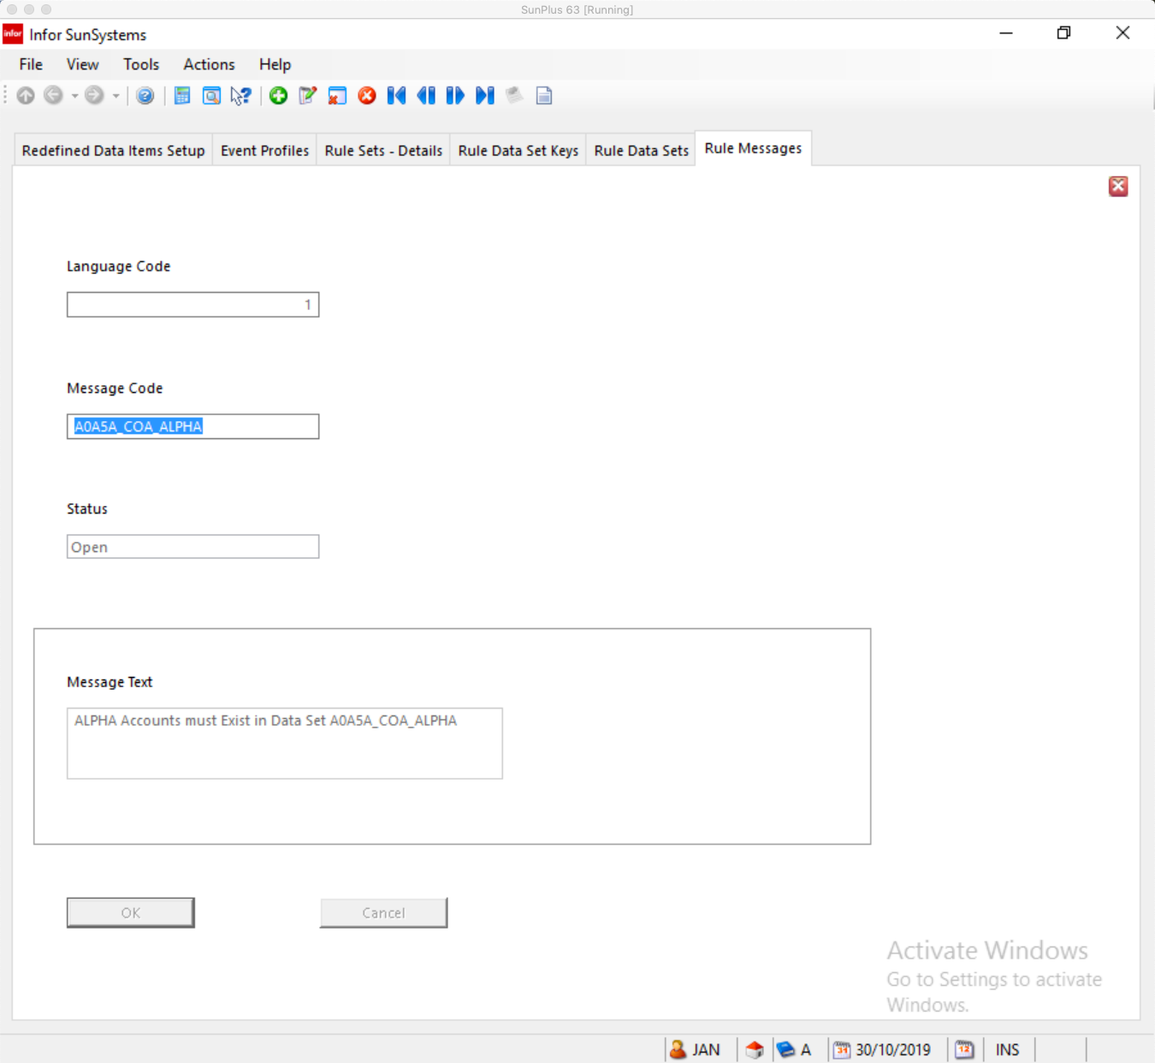

Rule Data Set Keys

Rule Sets define tables of allowable data, or valid combinations of codes. They are used in conjunction with Rule Data Set Keys to maintain indexed lists of valid combinations of selected data item values. Rule Data Sets are then used in Rule Sets as a simple way to check for valid code combinations on transactions being processed.

A Rule Data Set is a list of predefined valid values for one, two, or three key data items.

The key Data Items are defined in the Rule Data Set Key. Before setting up the valid code combinations, you have to use Rule Data Set Keys to identify the Data Items making up the combination.

For example, if you wanted to define valid Cost Center/Product Code combinations for transaction entry, the Rule Data Set Keys would be the Ledger Analysis Dimensions containing the Cost Centre and Product Codes as Key Data Items.

The Rule Data Sets would then define the valid Cost Center and Product Code combinations.

You can only use one Rule Data Set for each Rule Set.

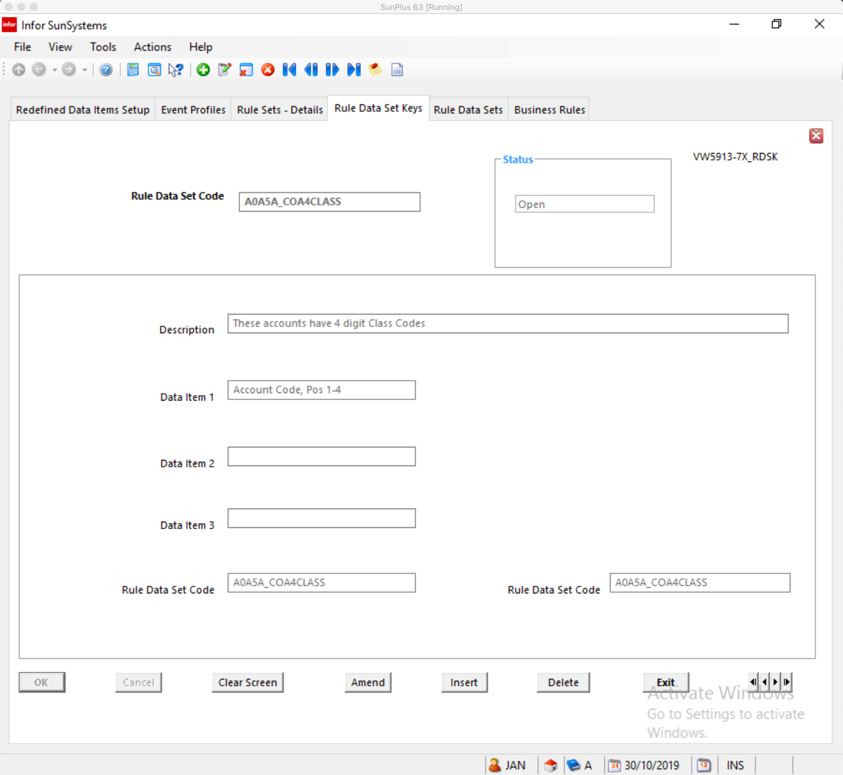
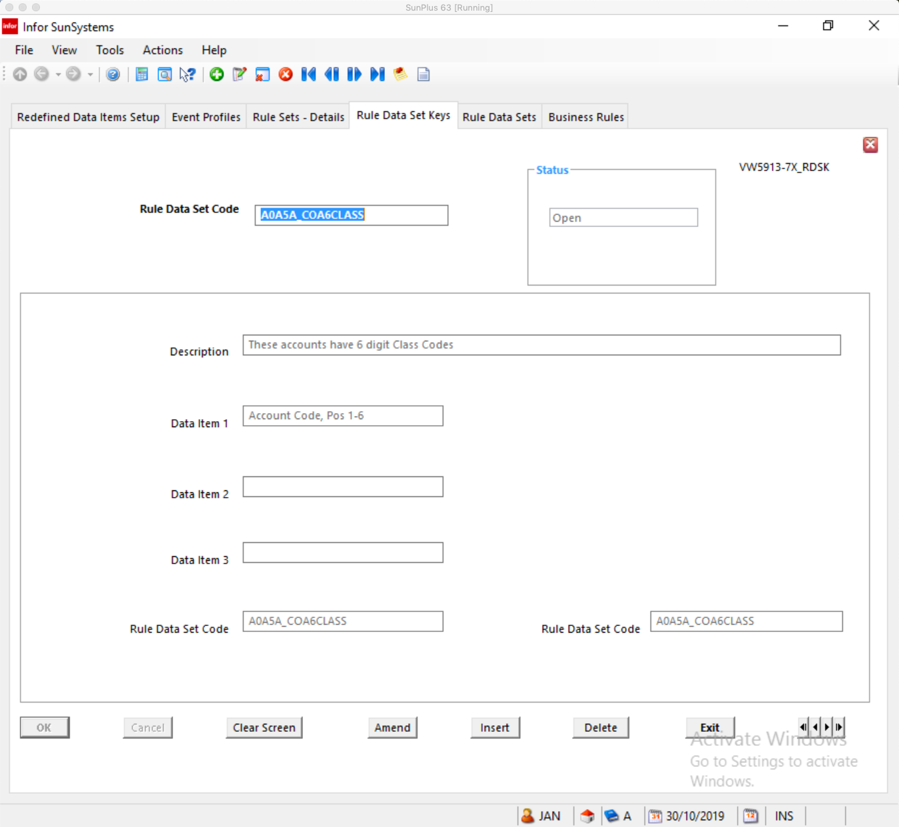

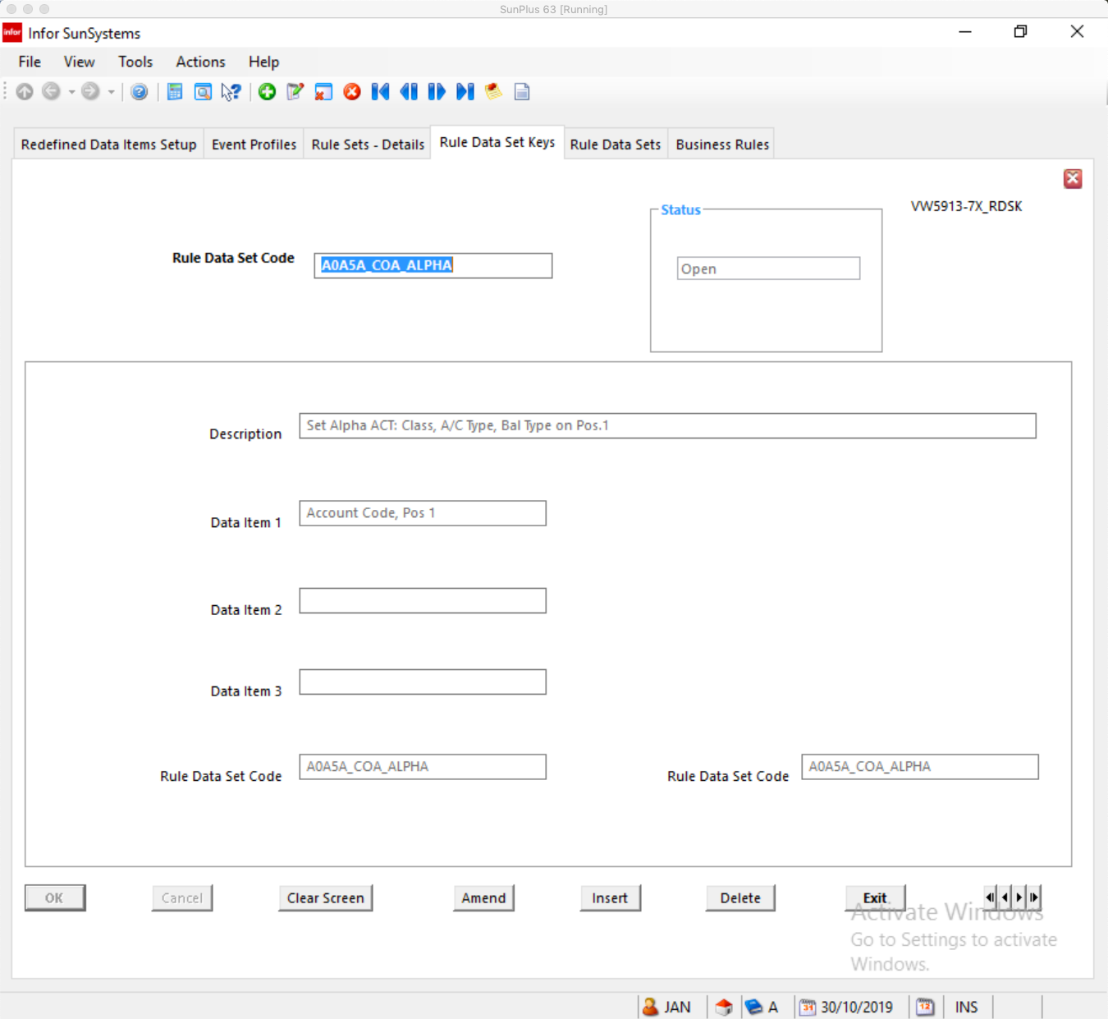

Rule Data Sets

See note on the Rule Data Set Keys above.

To reference a Rule Data Set in a Rule Set, Use an IF condition statement and select the Rule Data Set as Value 1. The keyword EXISTS is set automatically as Value 2 and is used to determine whether or not the current data record contains a valid code combination.

A number of Rule Data Sets are associated with the Sample Business Rule we are reviewing.

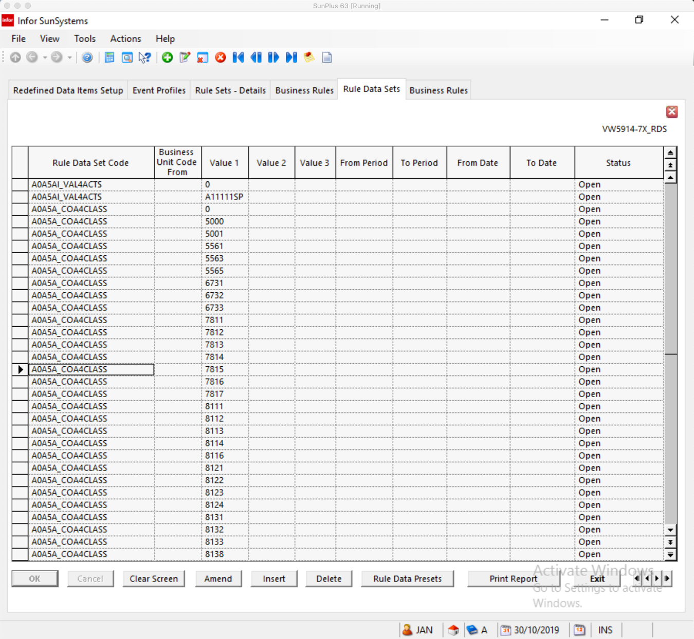
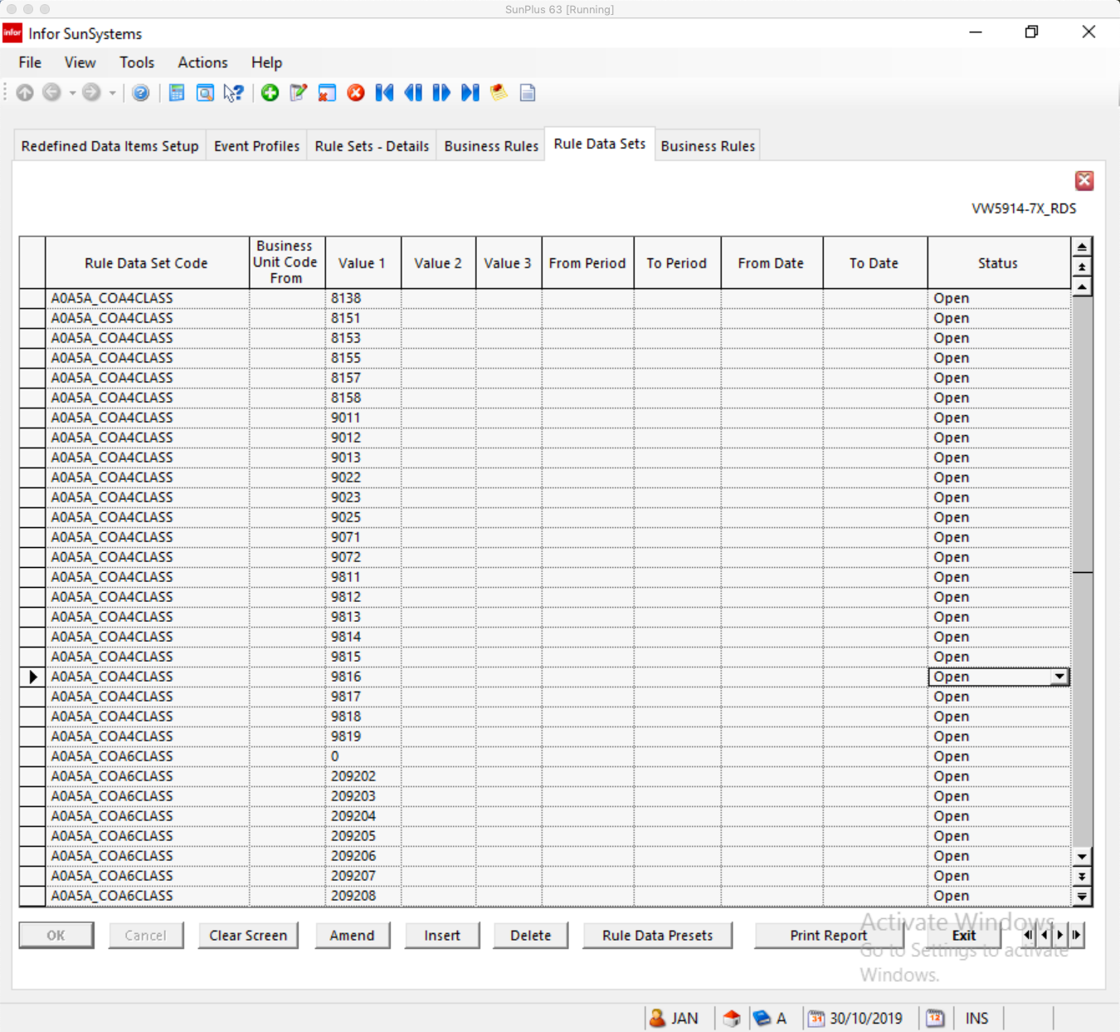
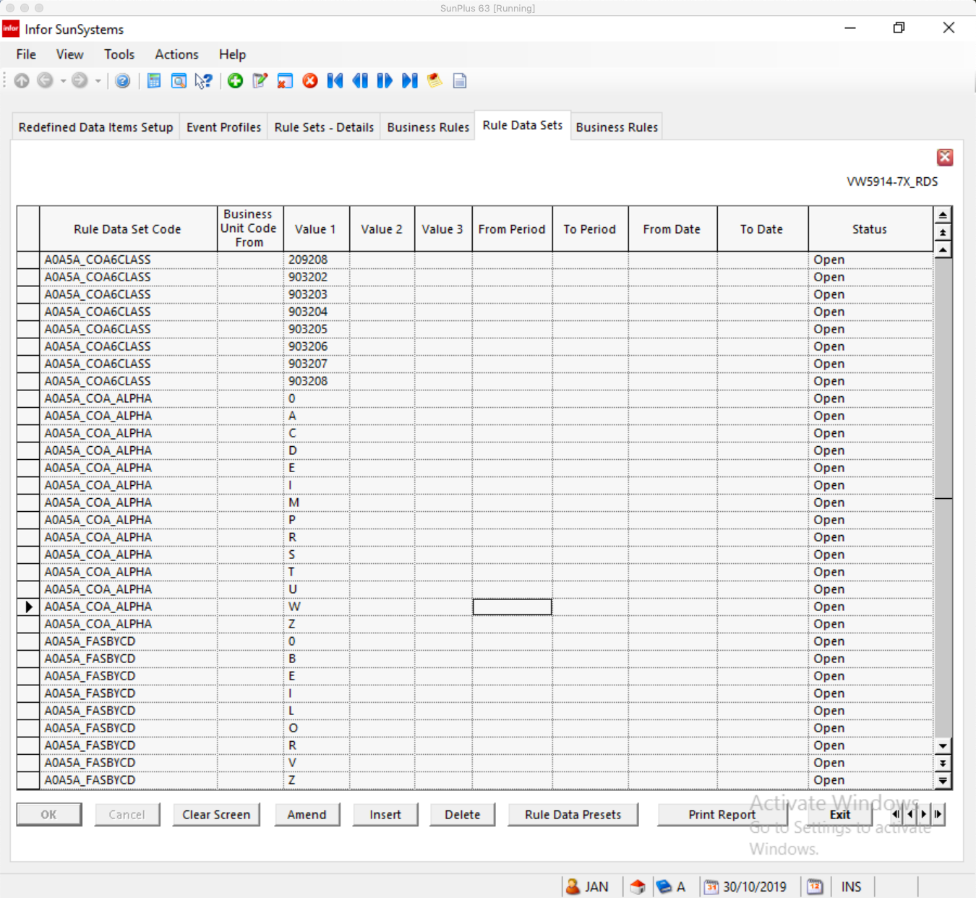

Rule Data Presets

SunSystems can be configured to insert data (force certain fields to specific values). The values to be inserted are defined with Rule Data Presets.

Up to 20 Data Item values can be set up for each Rule Data Set code combination. The SET command in a Rule Set is used to preset the values of other Data Items automatically when a particular code combination is found.

Several presets for the Sample Business Rule are below.

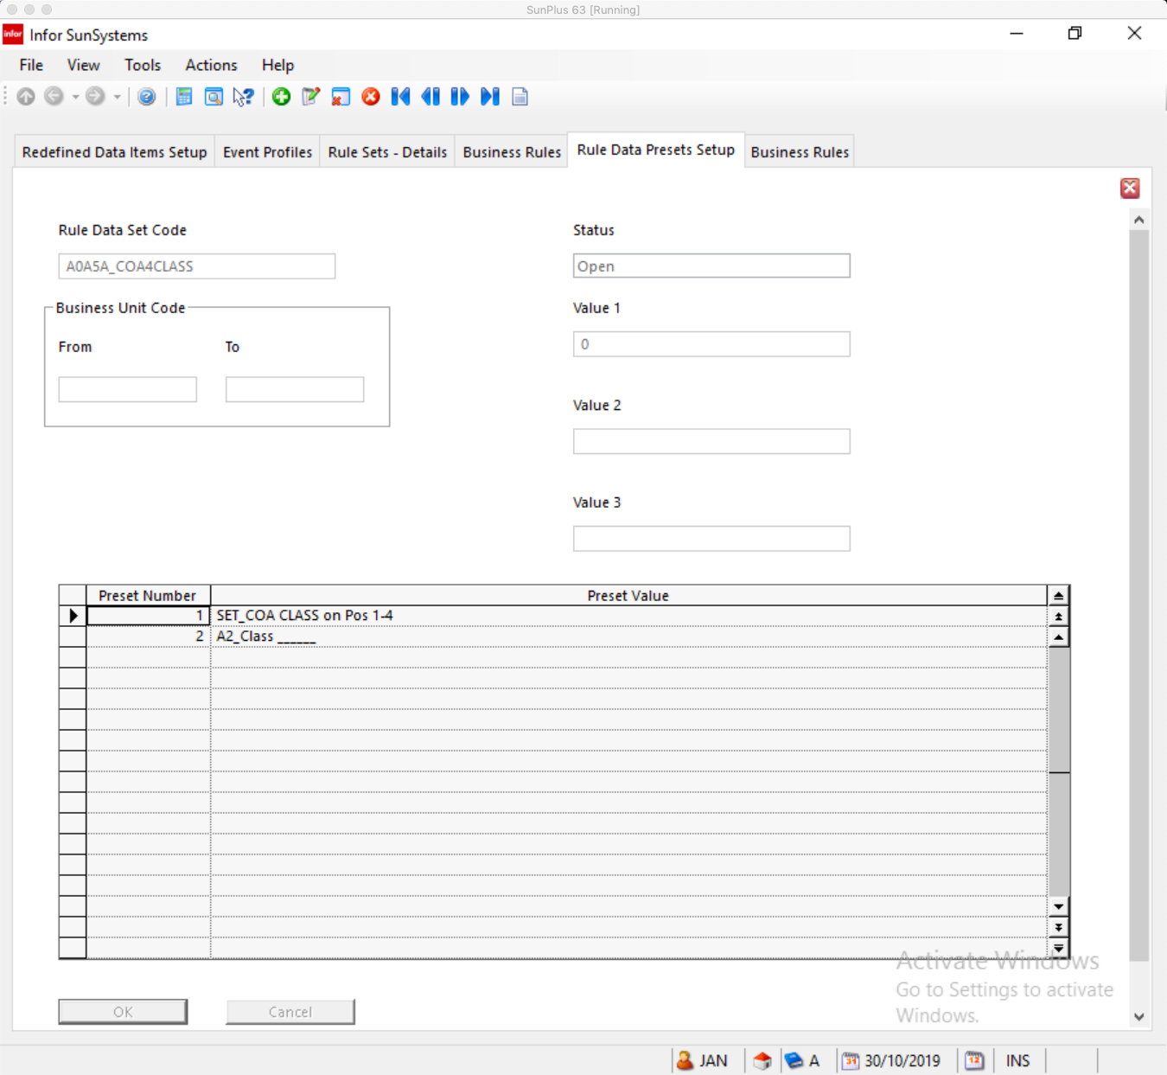
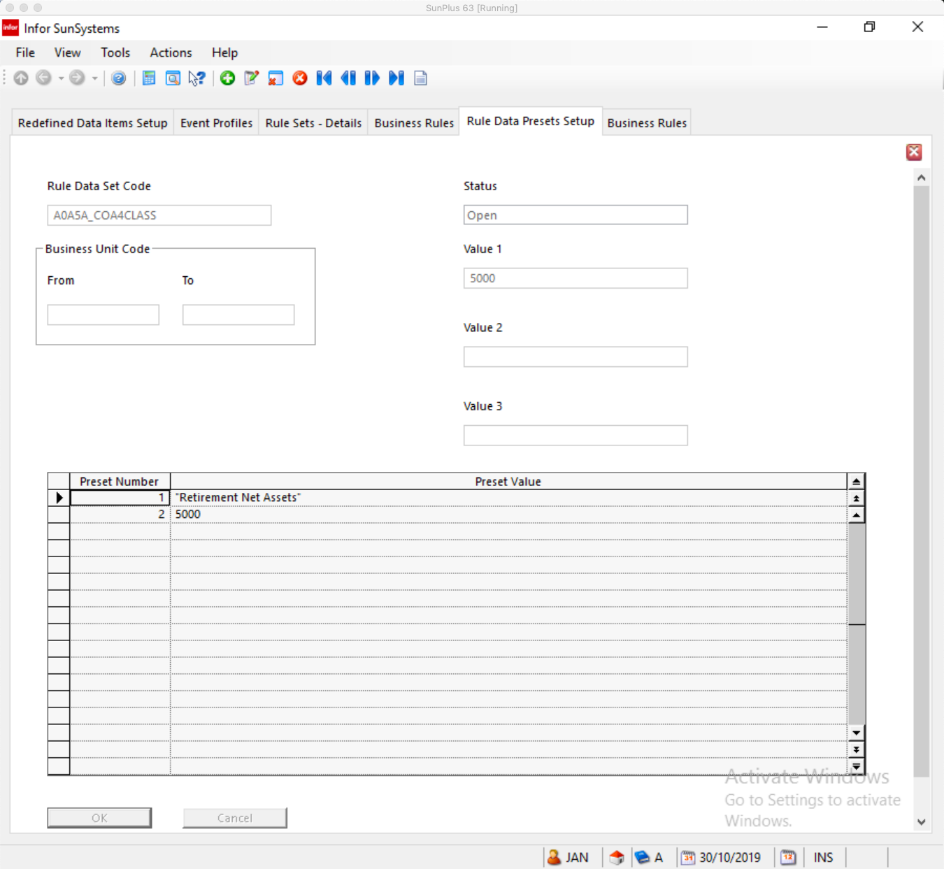
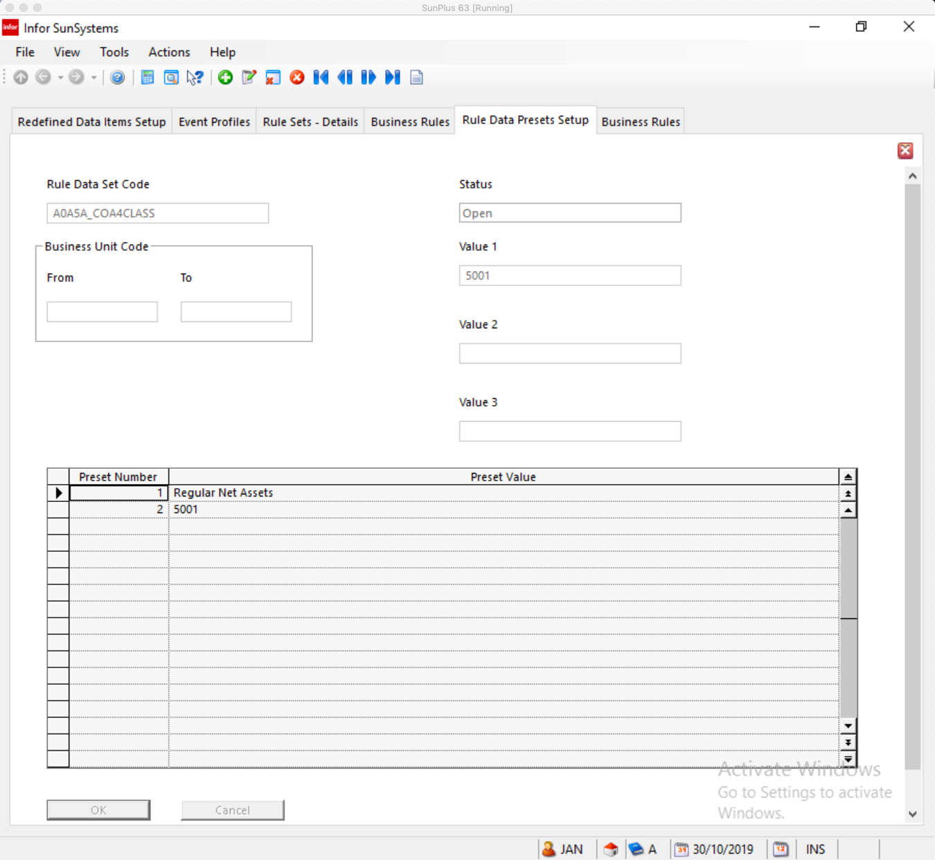
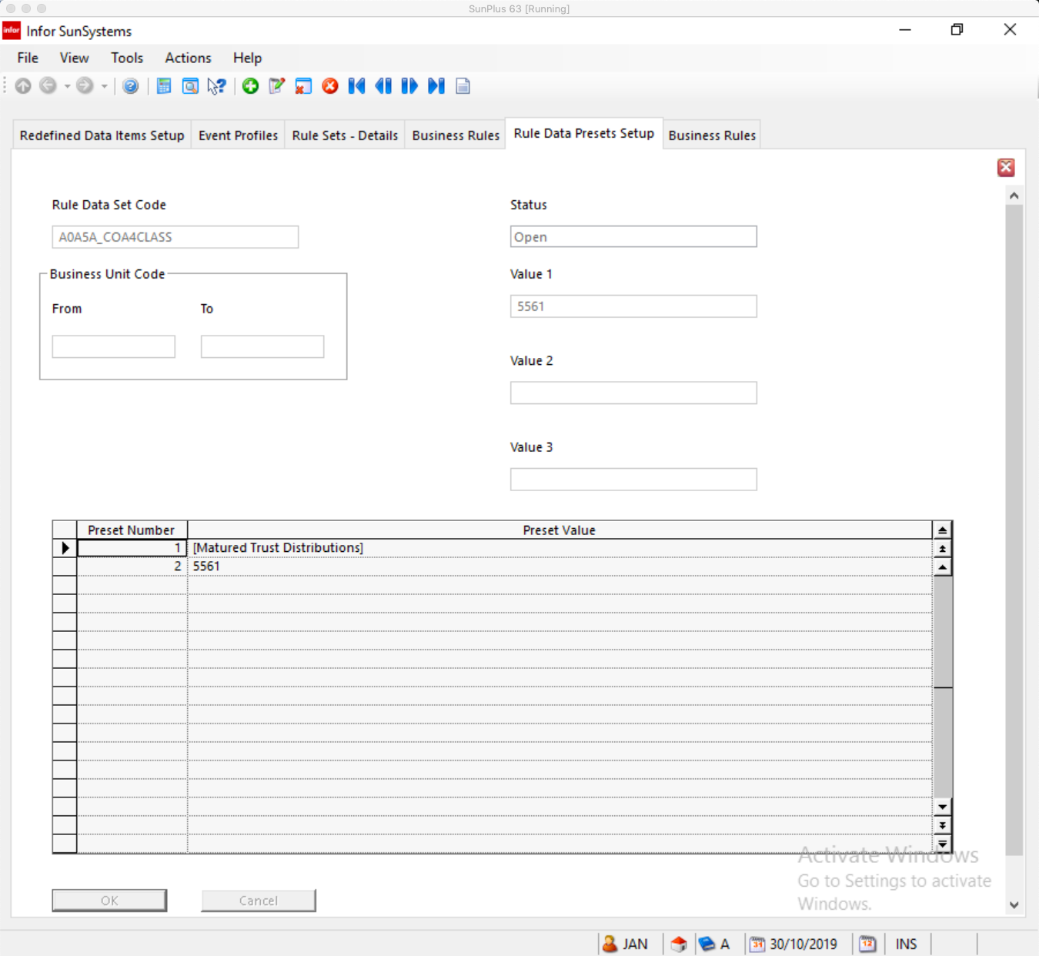
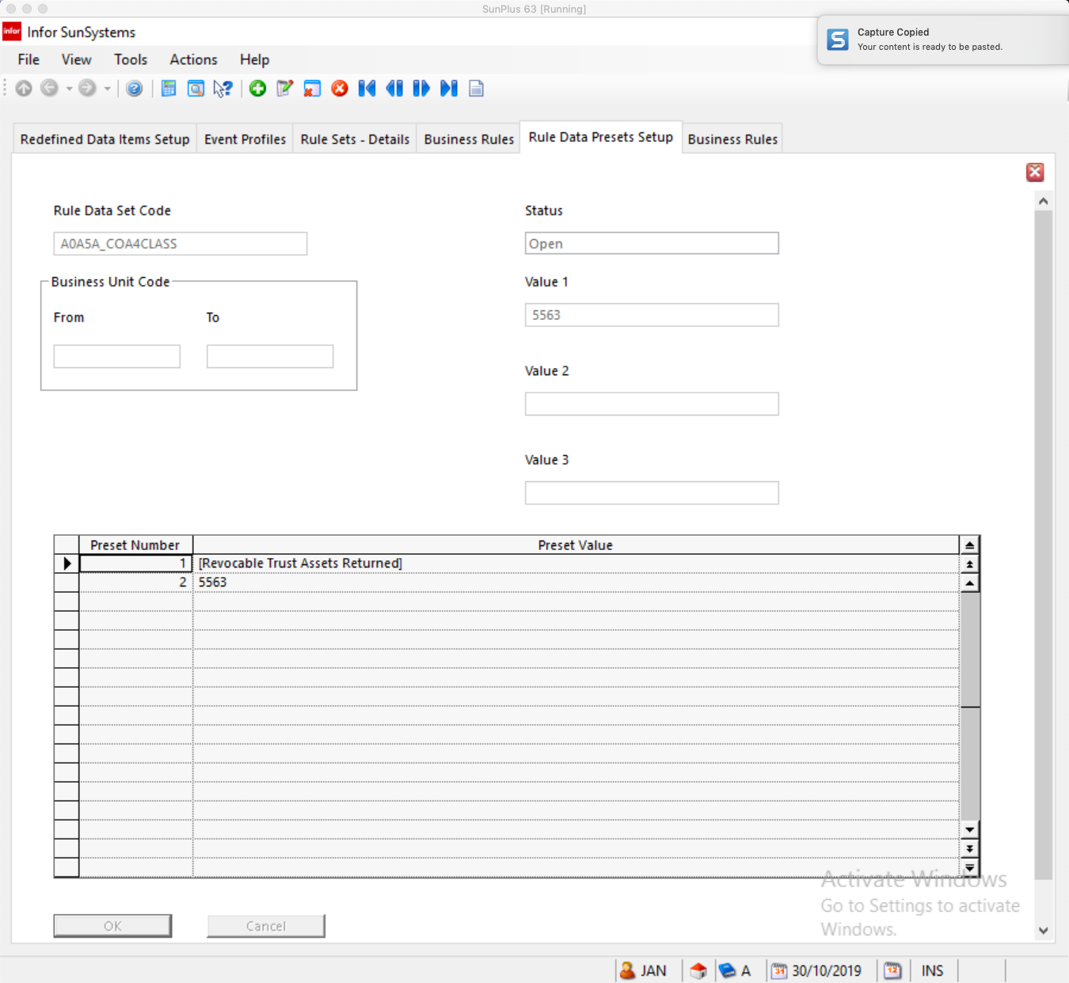
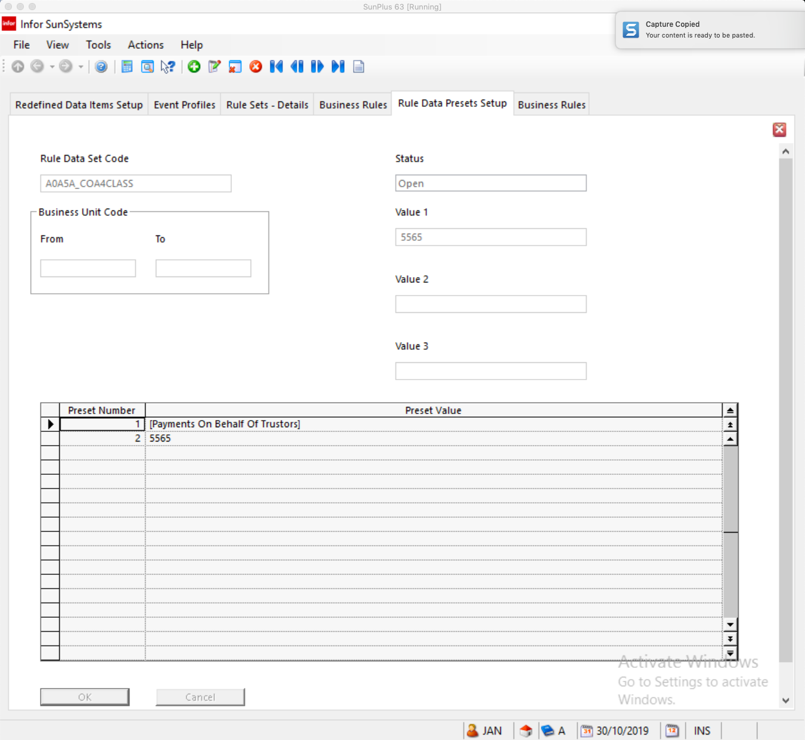
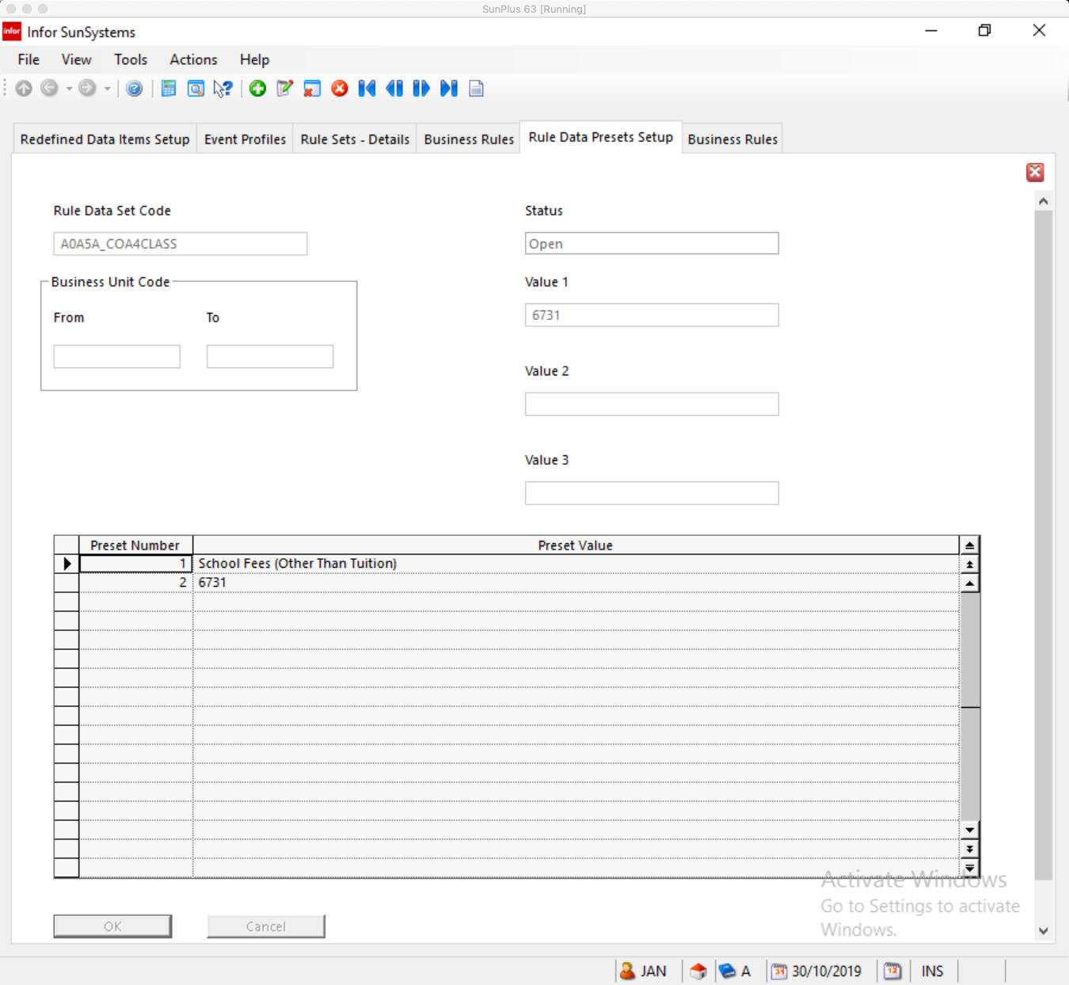
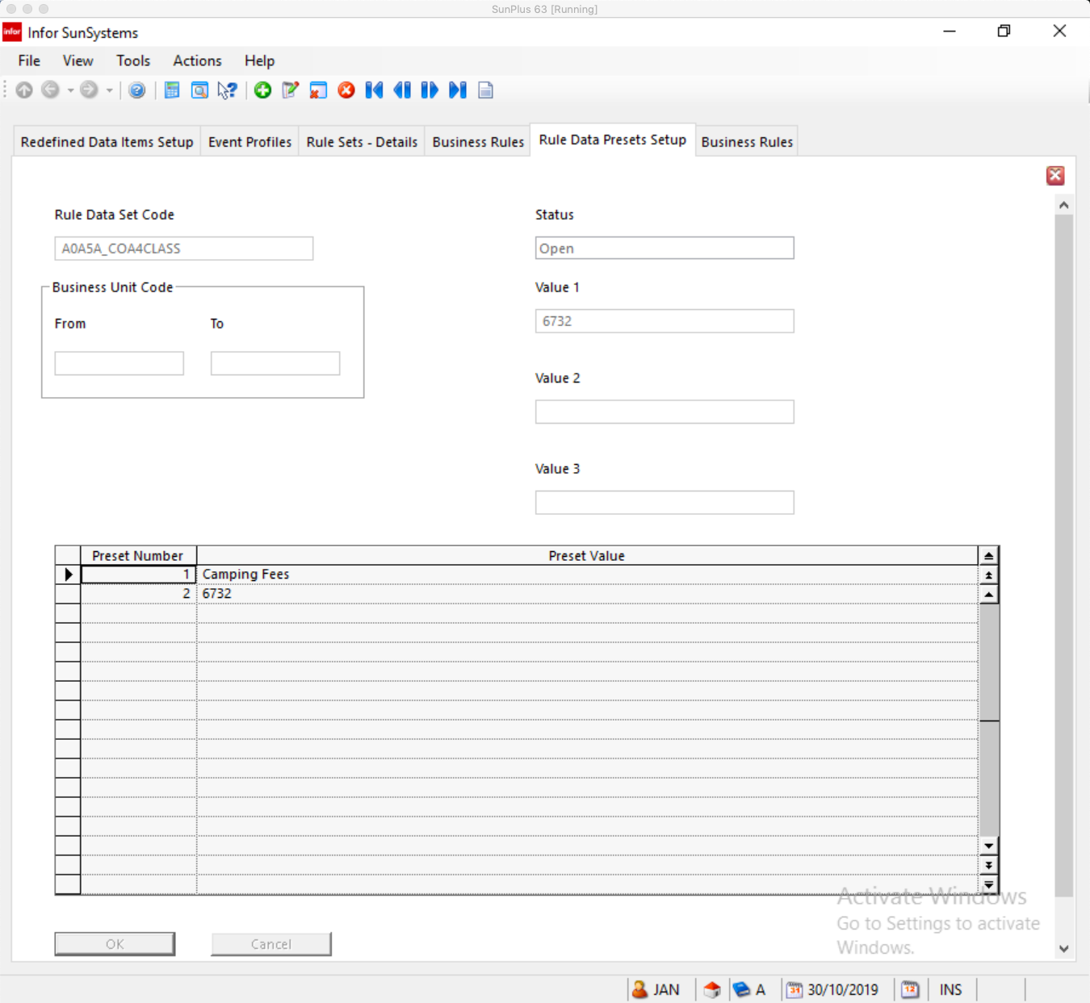
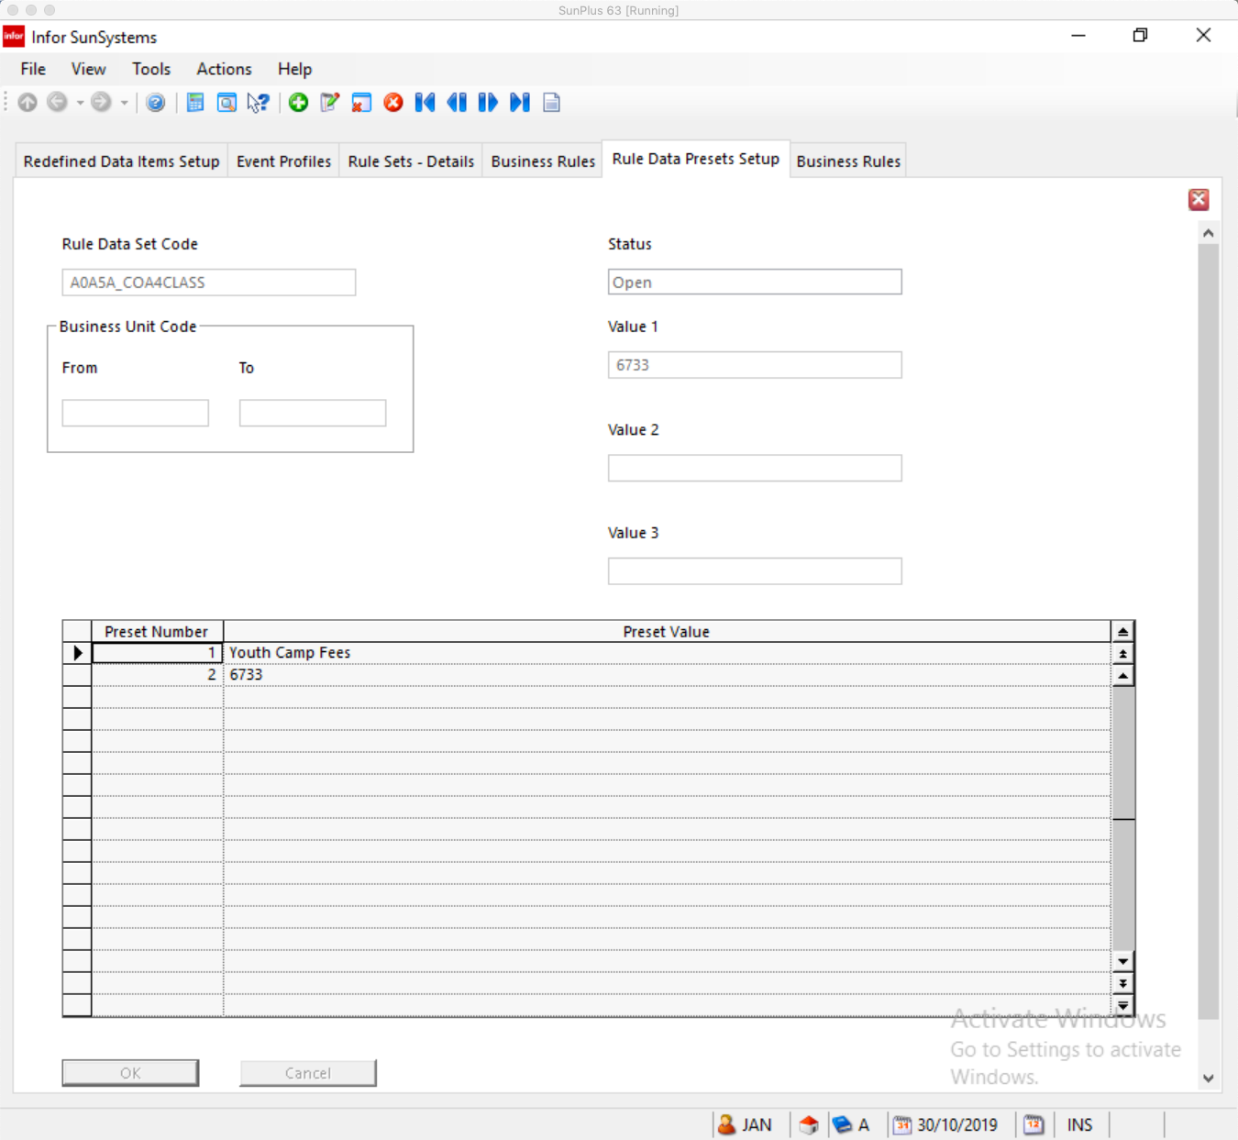
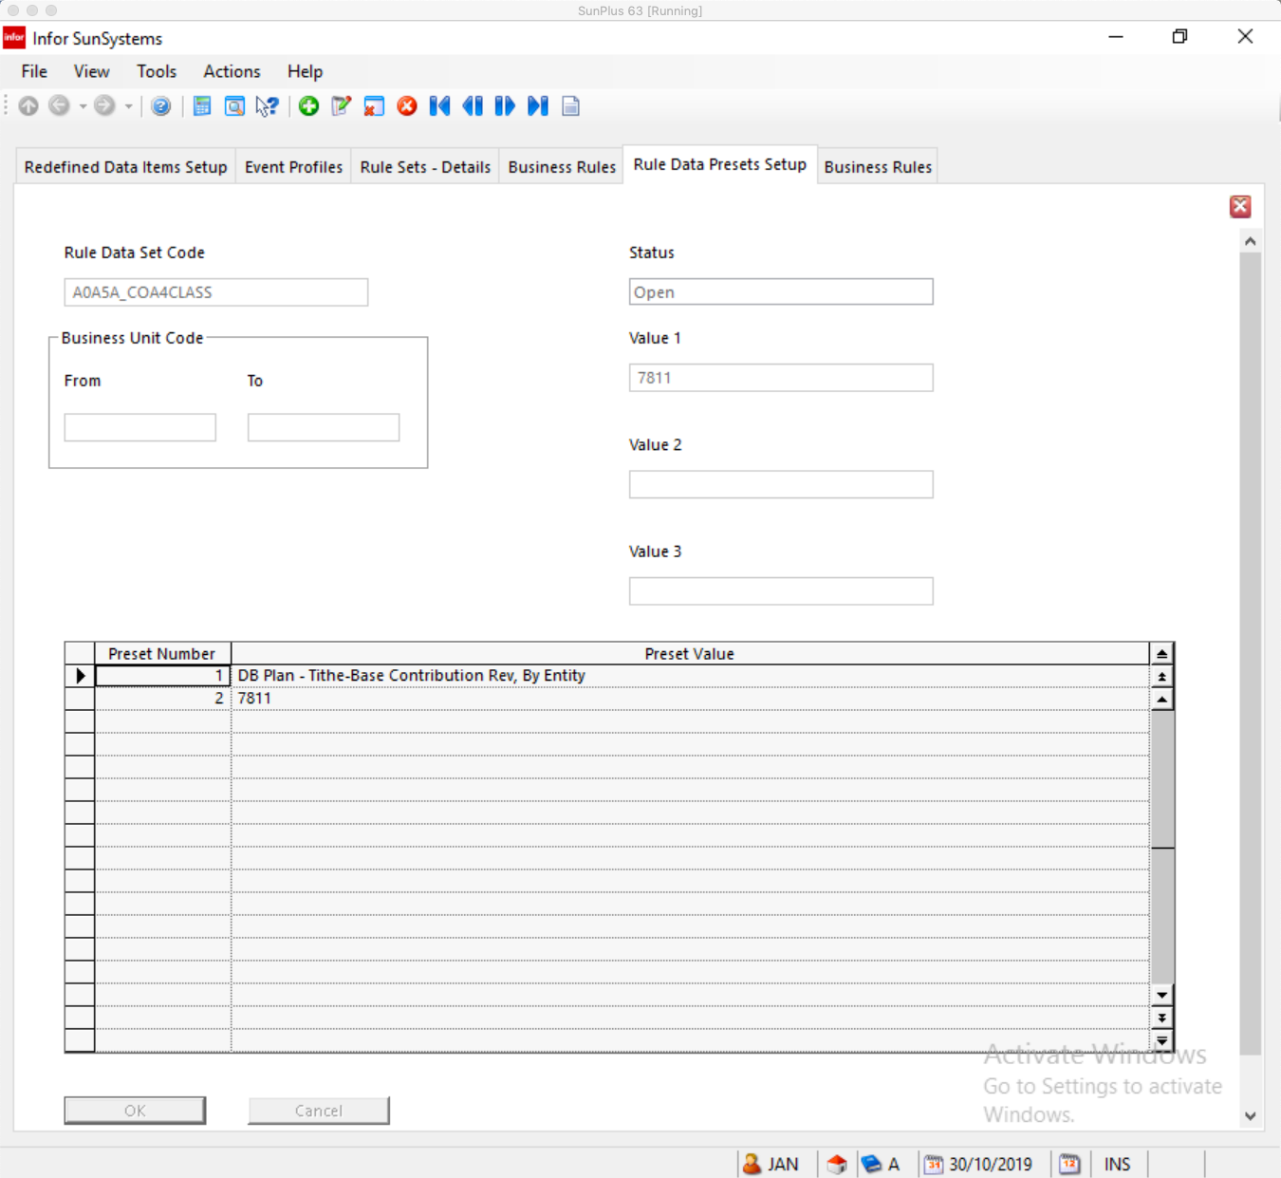
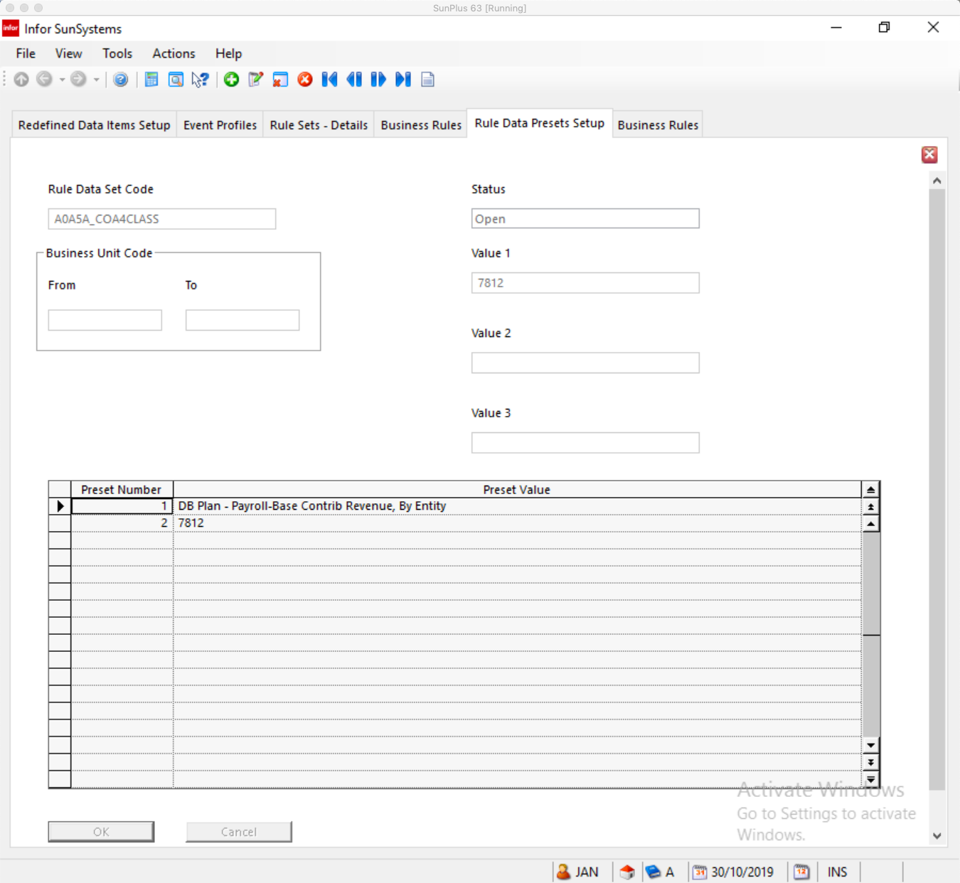
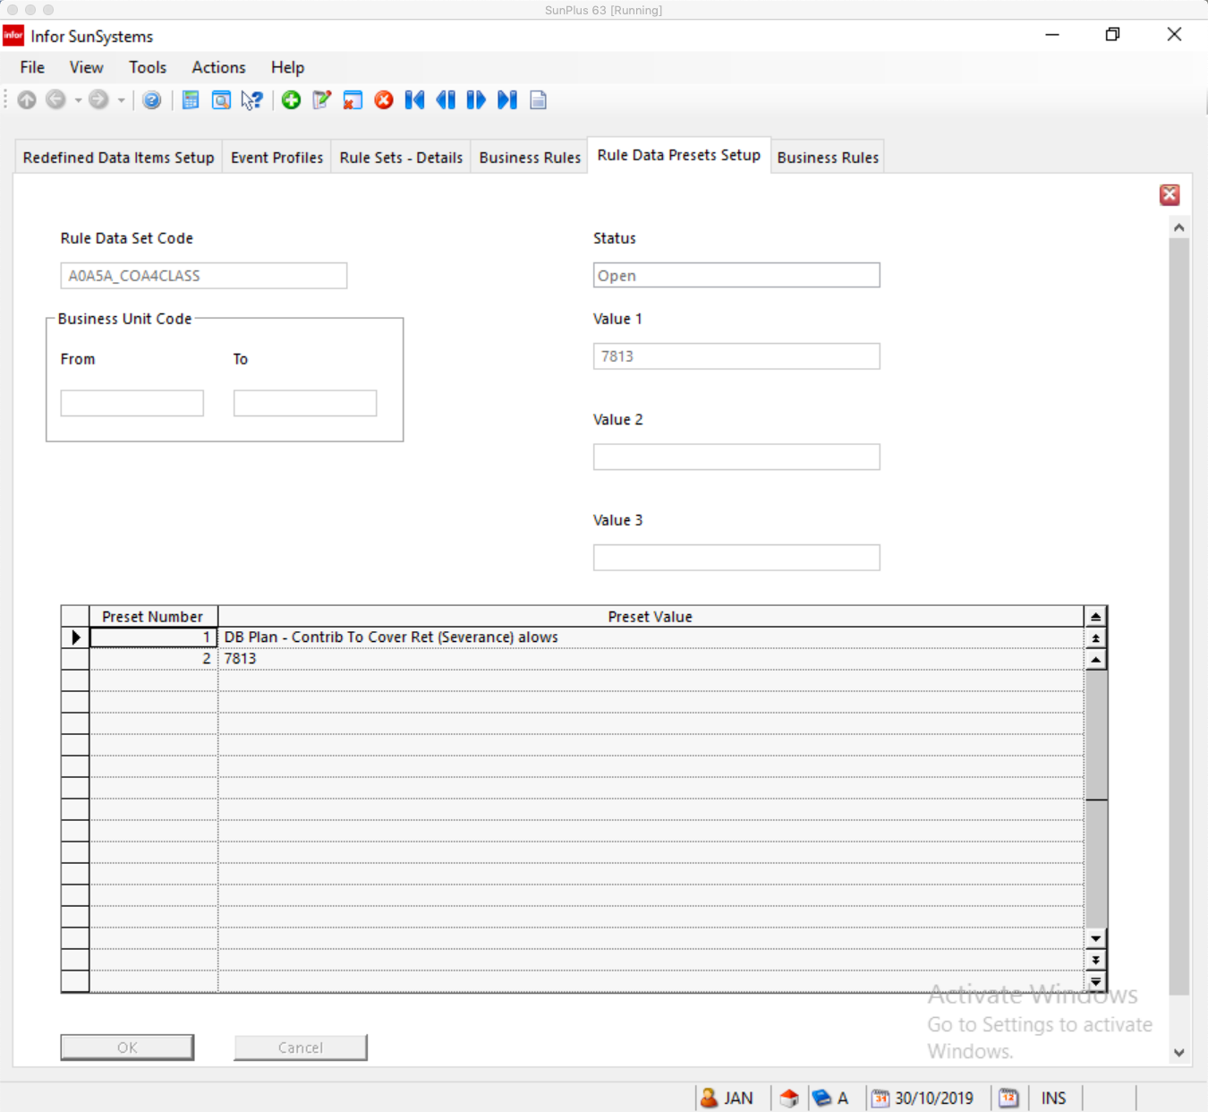
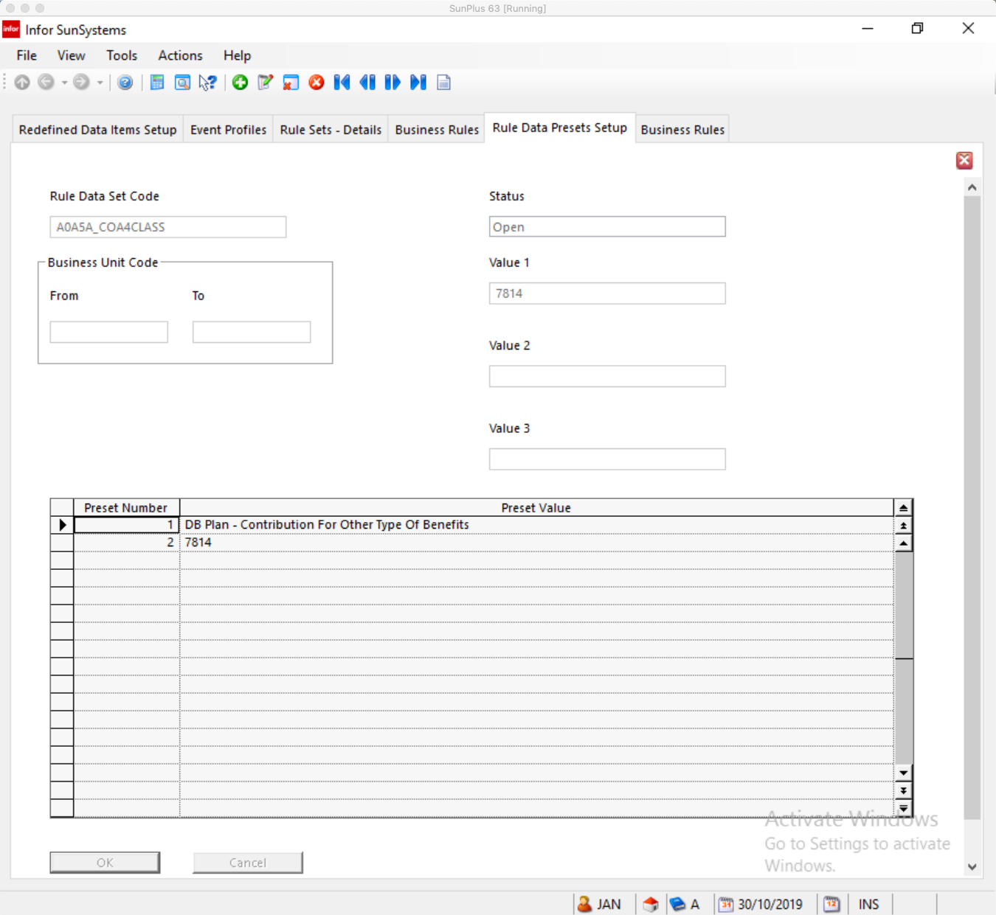
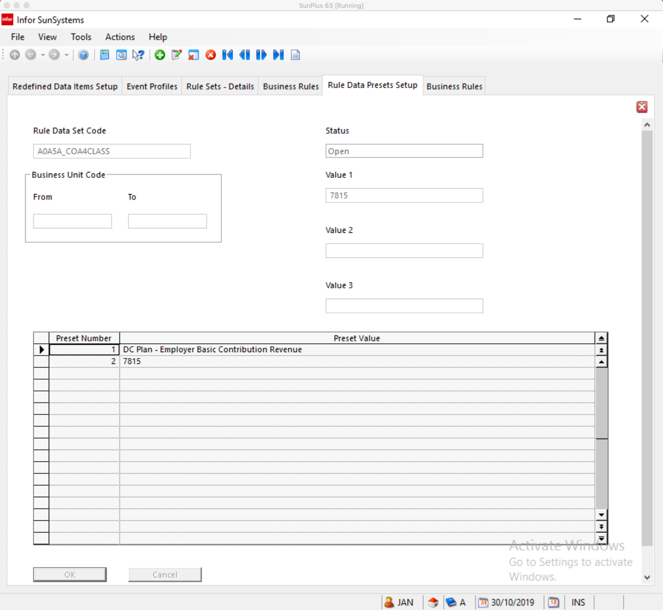
And so on to number 9819
